1. Download Axis2-1.6.2-bin.zip, axis-2-1.6.2-war.zip files from <http://axis.apache.org/axis2/java/core/download.cgi#a1_5_1>. Download as shown below

**Tip: Maximixze your MSWord then fonts will appear clearly(Observer right corner of word and increase 100 to any value as you like)**

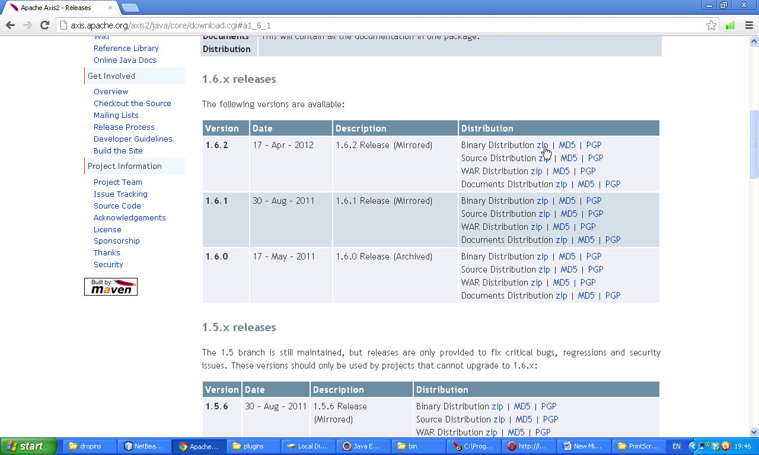

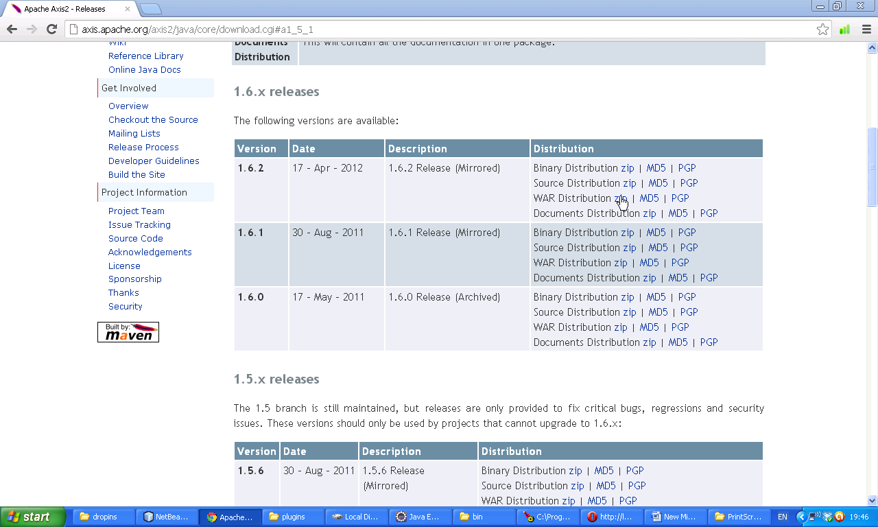Now two zip files are available for us. Extract them we will get axis2.war and and axis2-1.6.2. Now open Axis2 war extraction

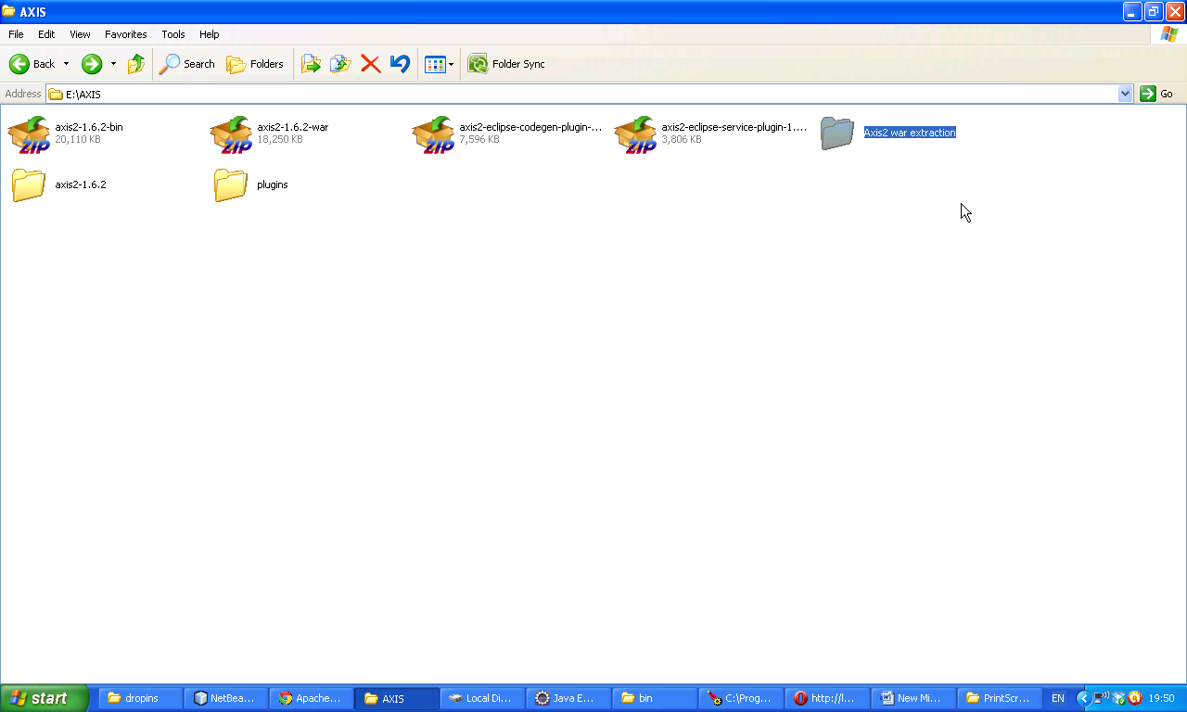

Now following war file is available.

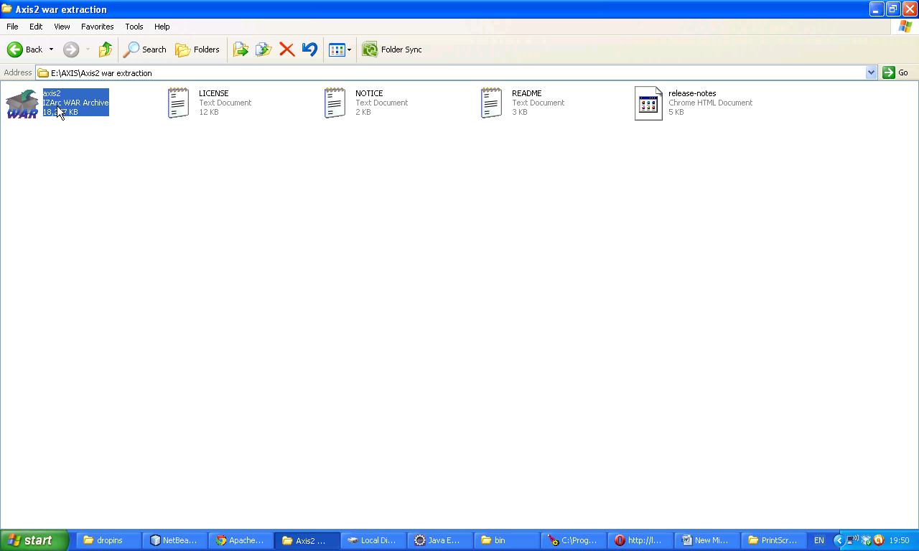

Now paste the axis2.war file in Tomcat/web apps folder. Now open Tomcat for confirmation. Type following url.

<http://localhost:5050/axis2/>

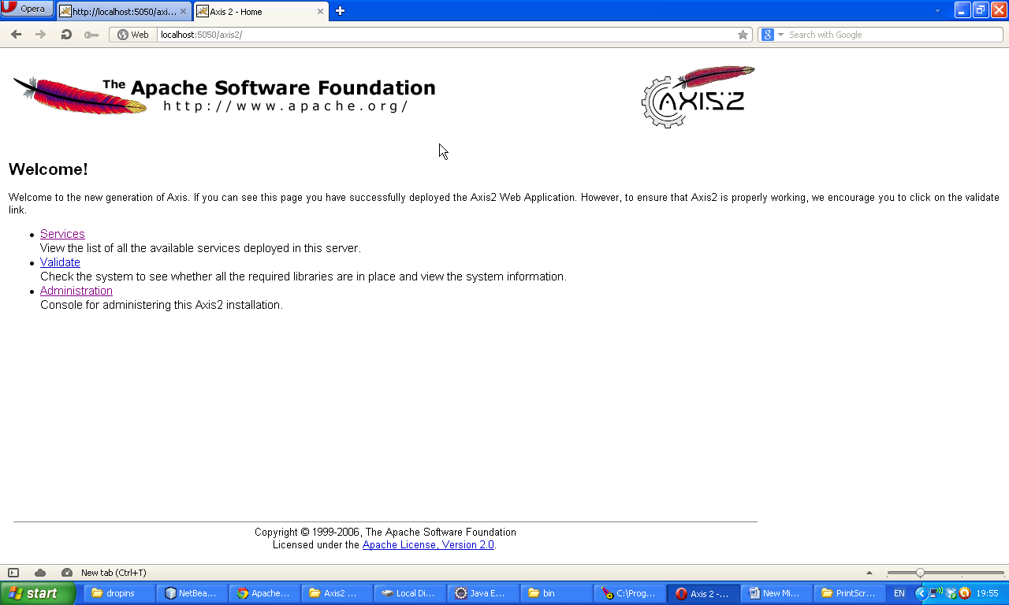

Now keep MyEclipse 9 or Eclipse Helio IDE ready in your computer. Which is available in

After downloading software we will get following zip file eclipse-jee-helios-SR2-win32. Now extract it.

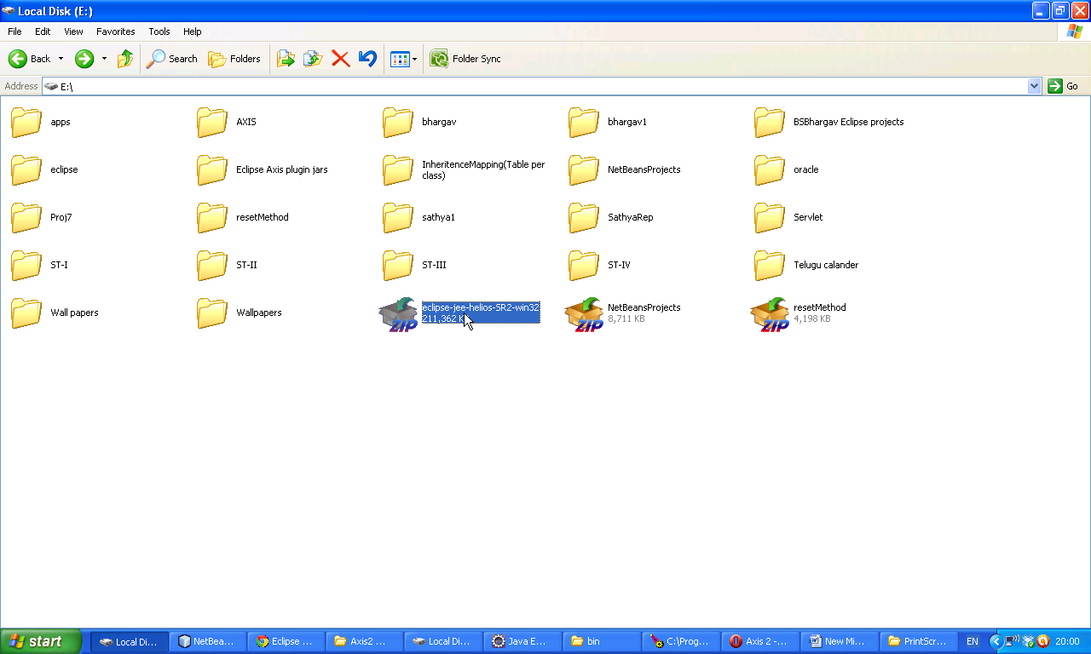

Following folder will come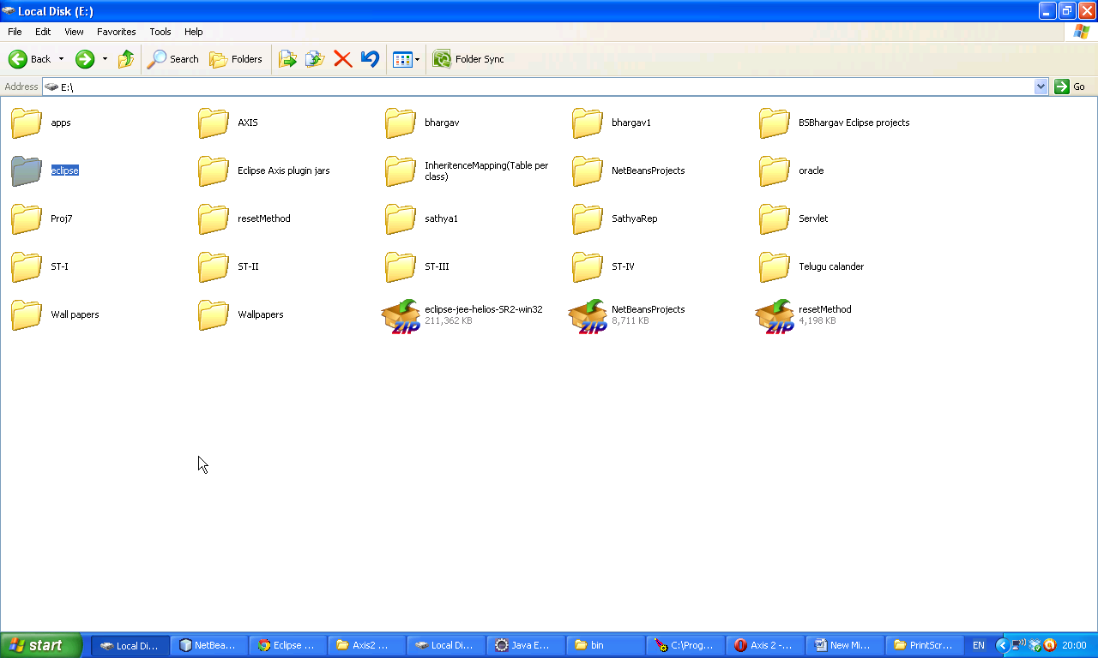

Now Download Eclipse Helios IDE(eclipse-jee-helios-sr2-wind32.zip). Type following url on browser <http://www.eclipse.org/downloads/packages/eclipse-ide-java-ee-developers/heliossr2>. Now following window will be displayed. Now select Windows 32 bit for XP

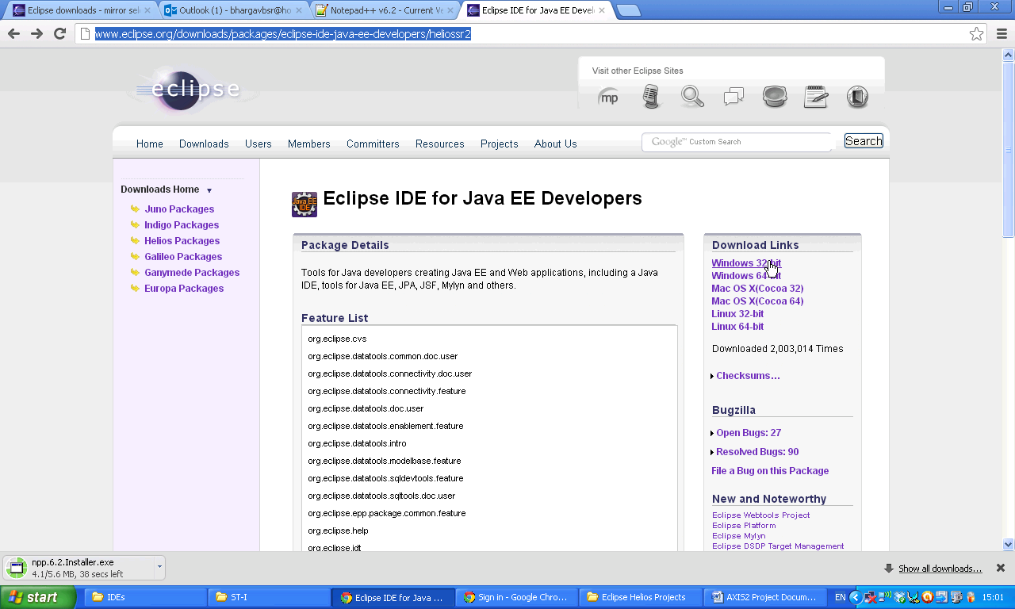Now select first one as shown in screenshot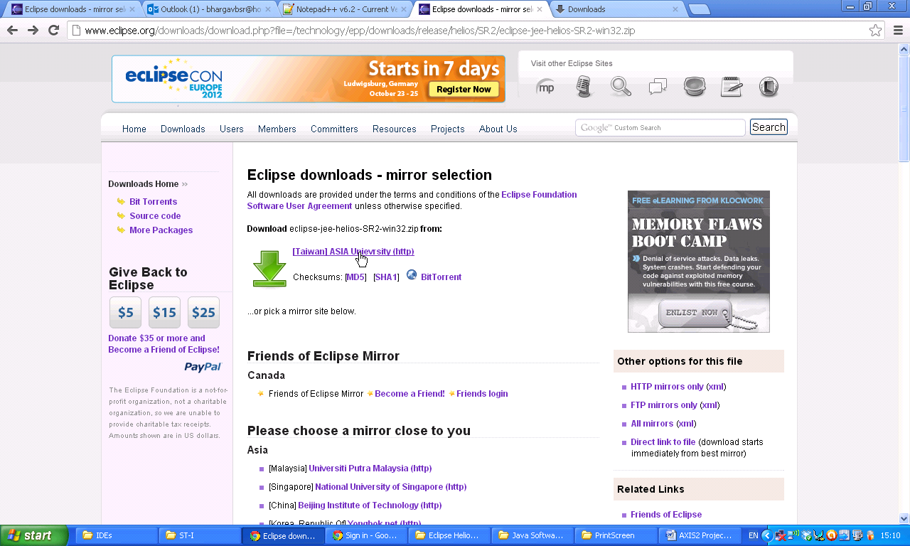

Now your download will start automatically. After downloading save it in separate folder.

Now dowload Axis plugins(axis2-eclipse-service-plugin-1.6.2.zip,axis2-eclipse-codegen-plugin-1.6.2.zip) for Eclipse Helios IDE. Which are available in <http://axis.apache.org/axis2/java/core/tools/index.html>

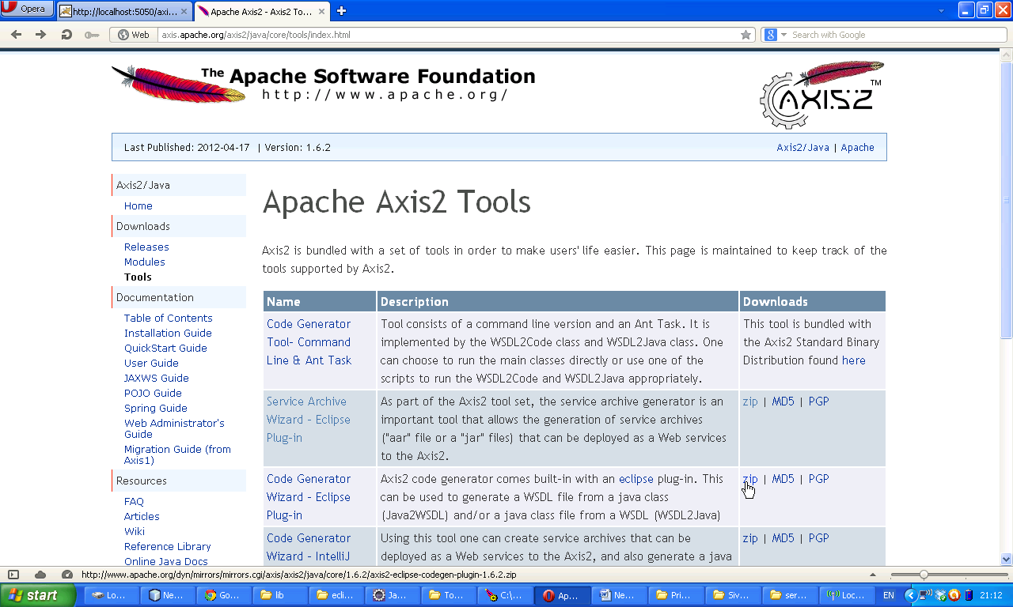Select First url.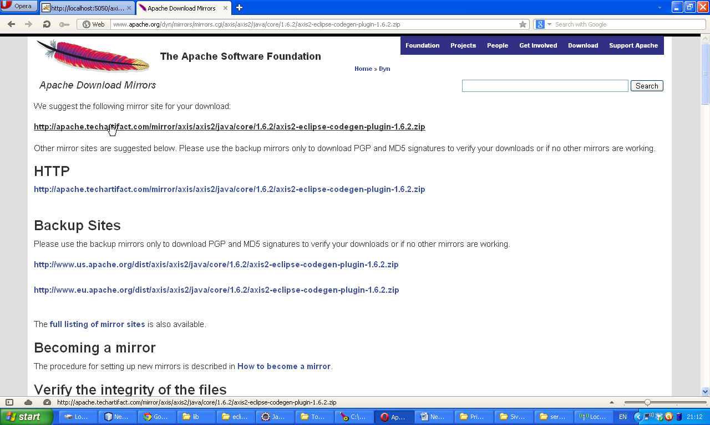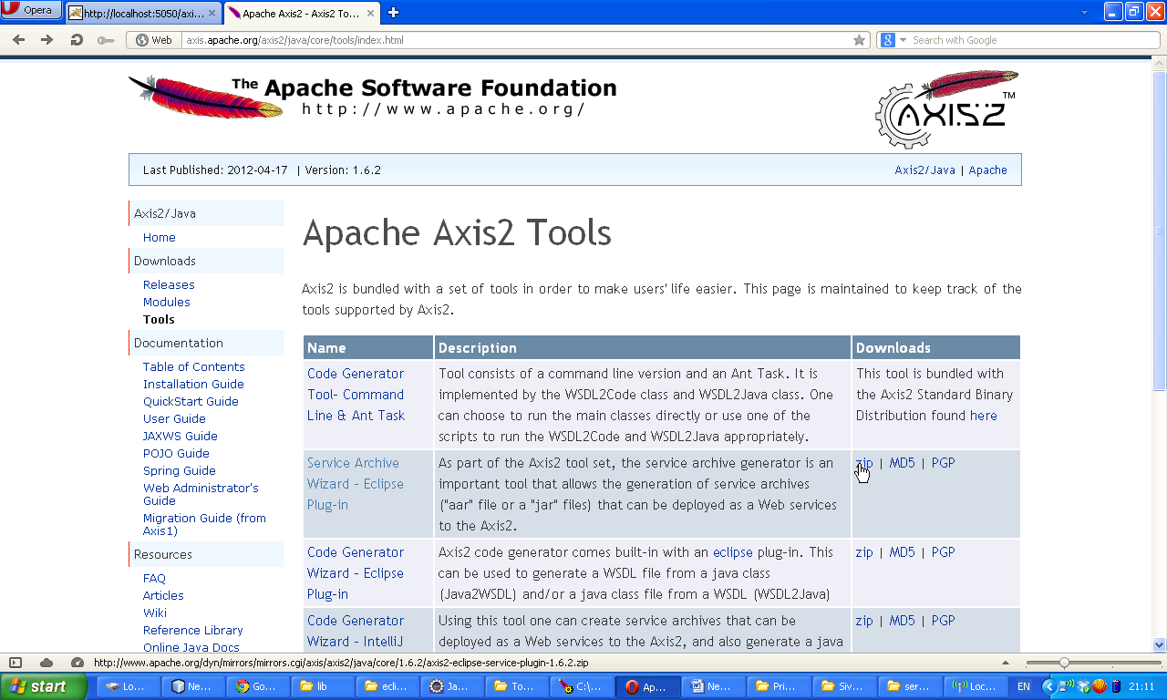Select first url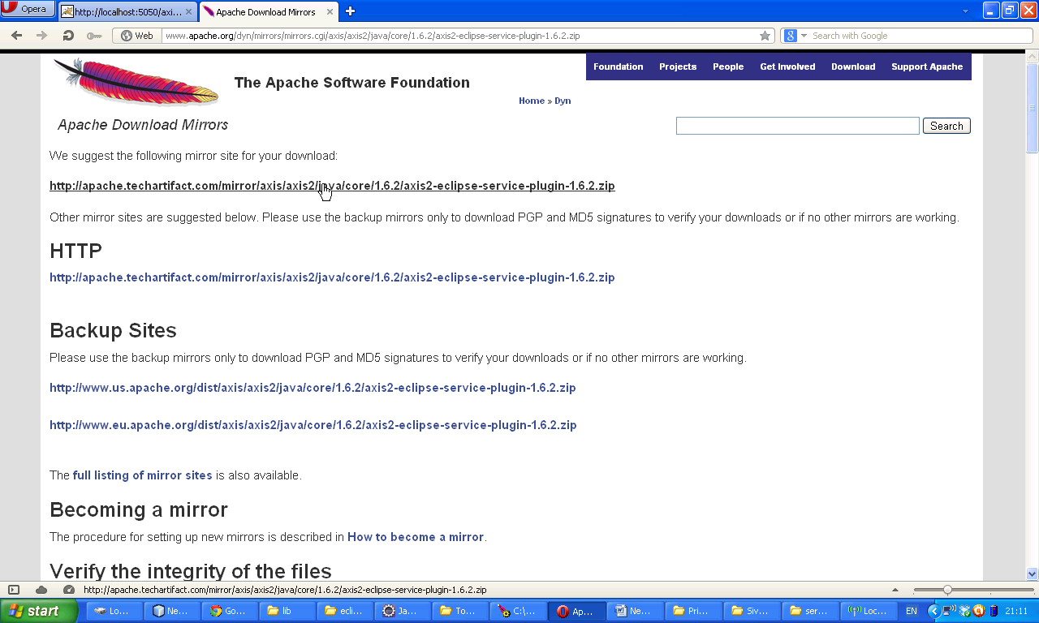

Extract the zip files and get jar files representing jars

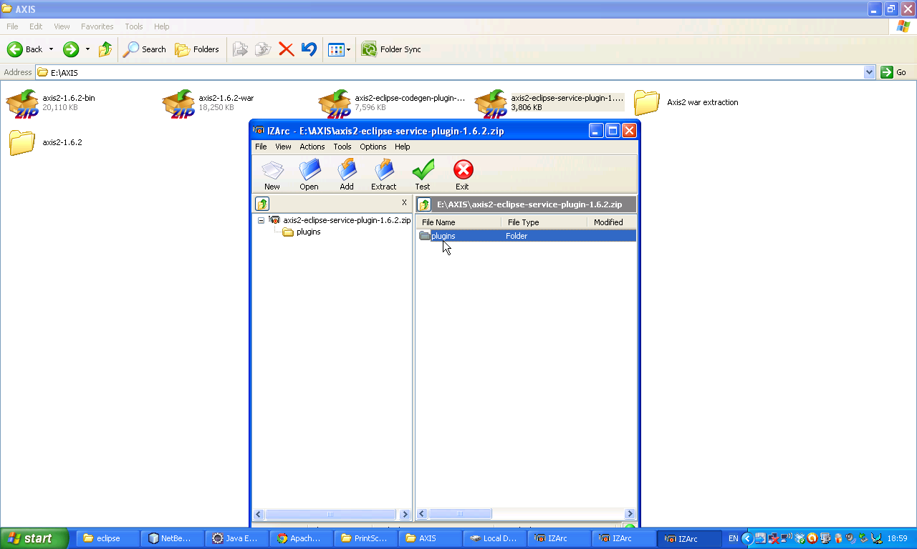Now Plugins folder will come open this particular folder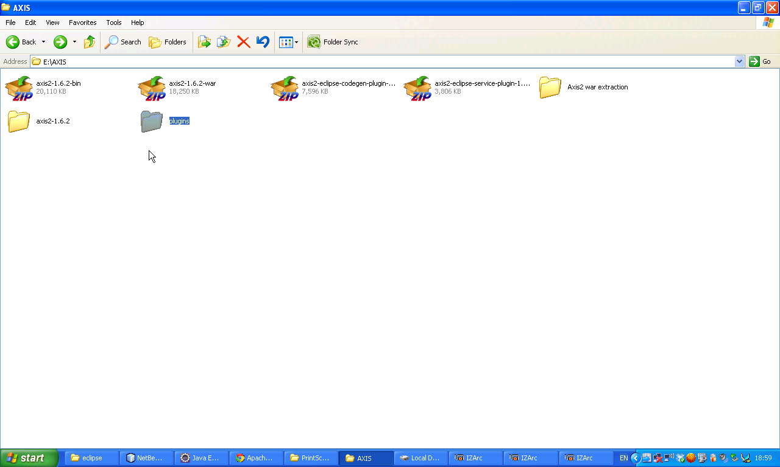

\

We will get following jar.

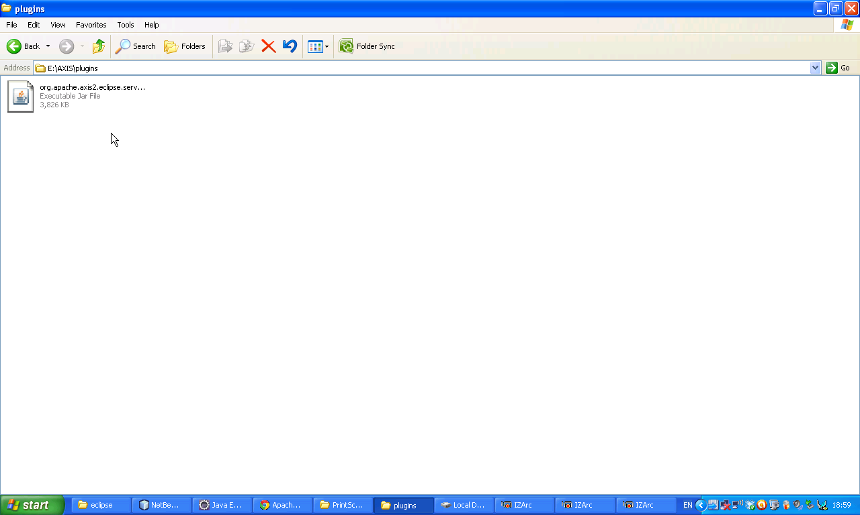 Copy it 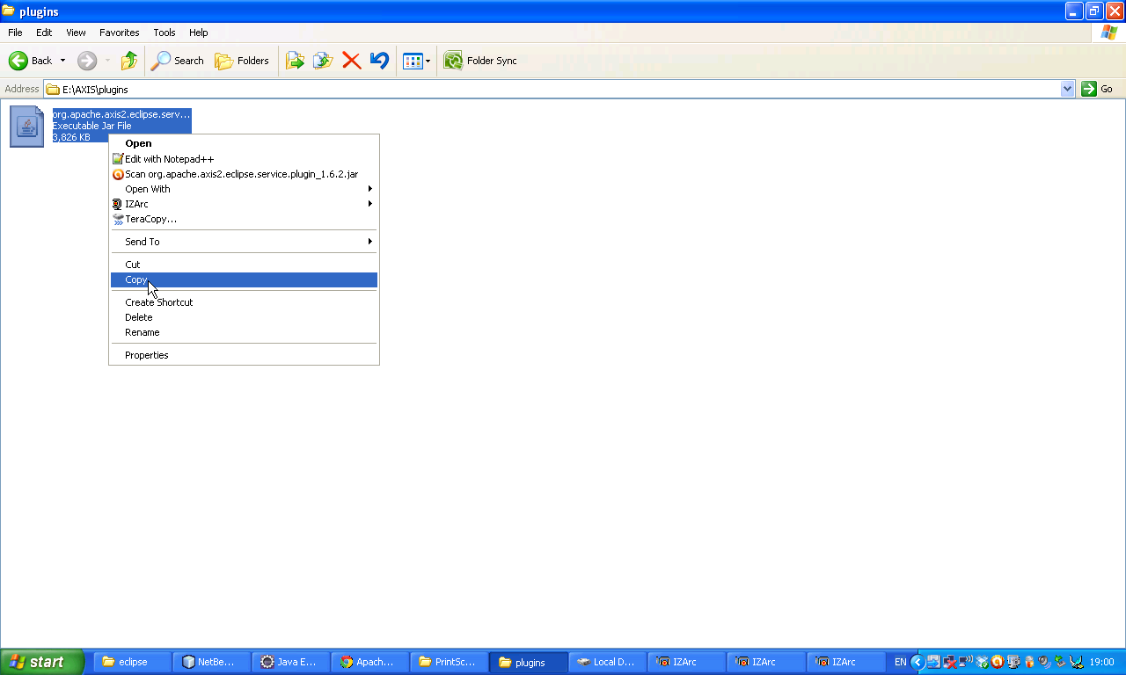

Paste in E:\Eclipse\dropins 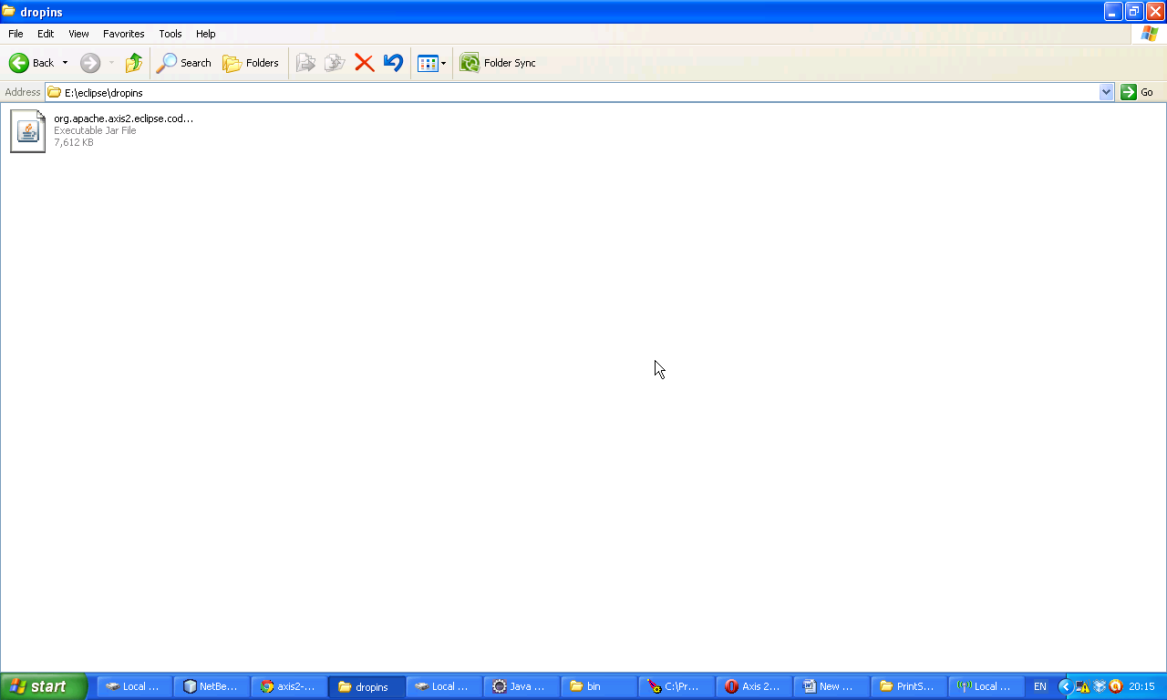Now Extract anoth er zip file 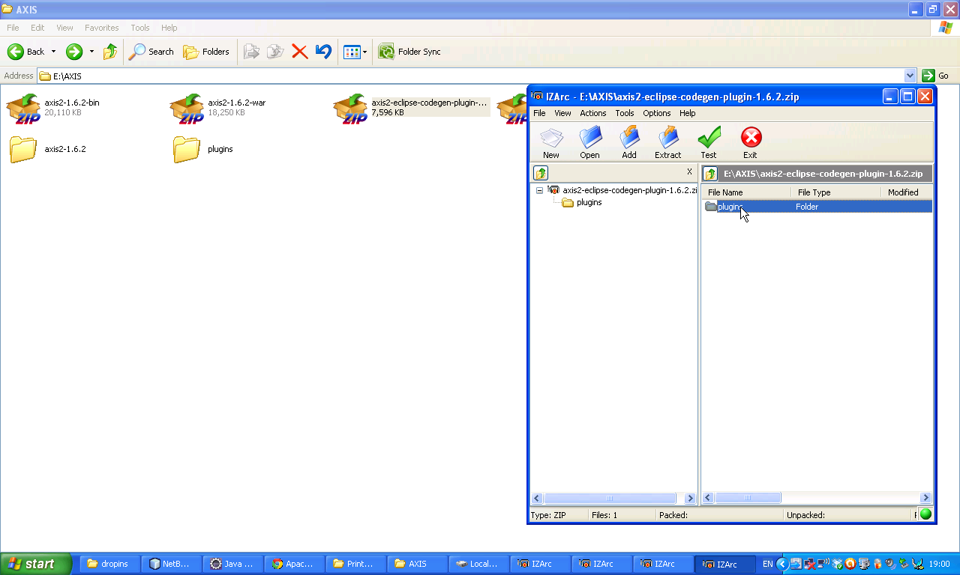

It will ask some thing click yes to all.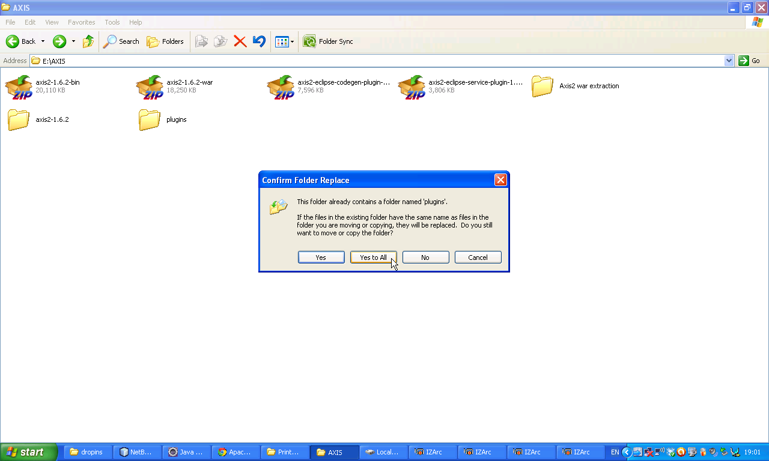

Now following plugin will come open it .

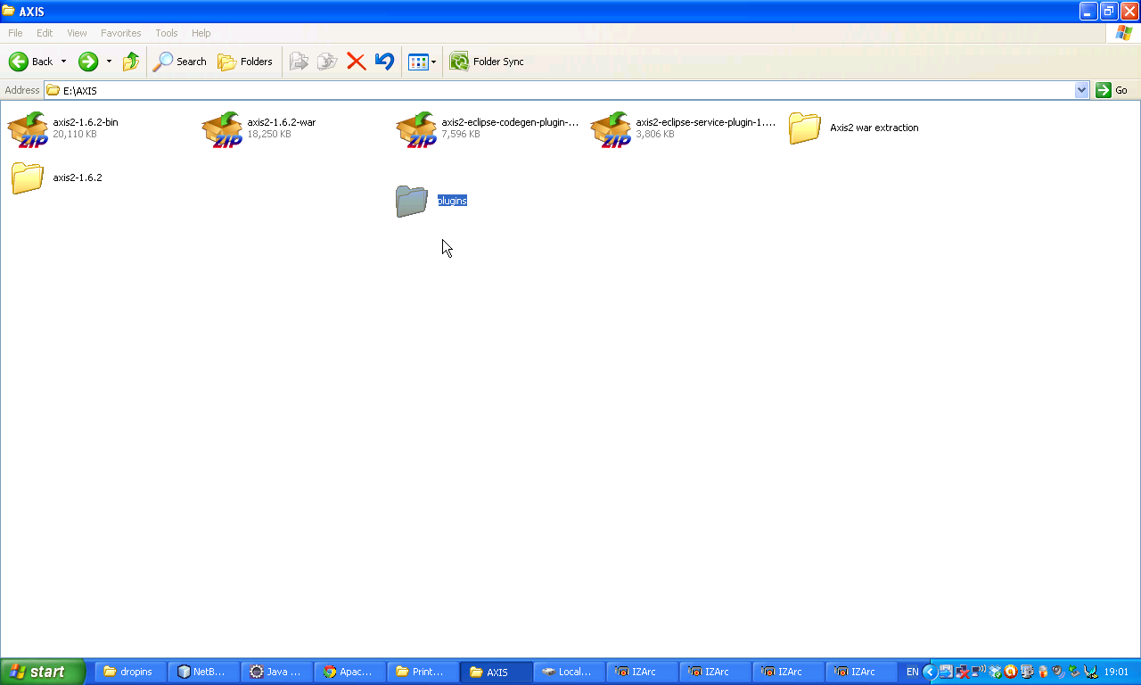

Copy it

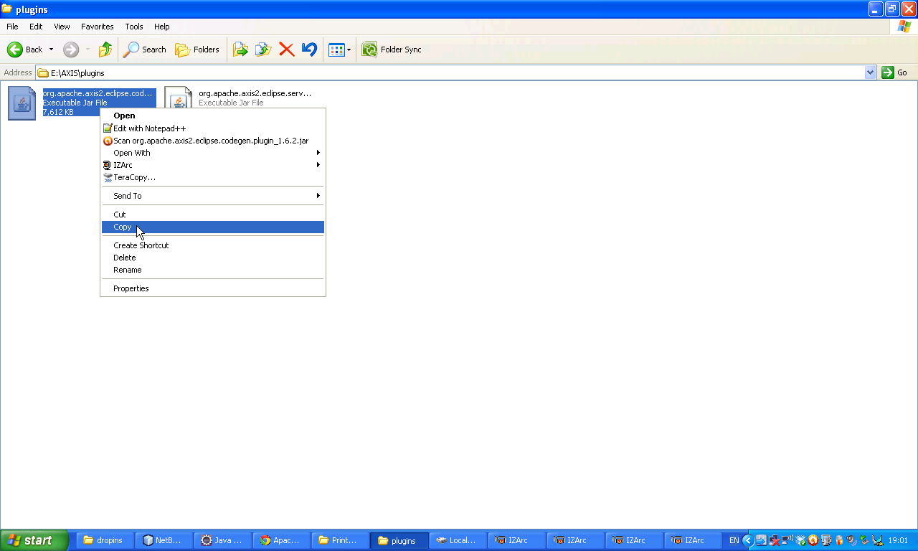Paste it in E:\eclipse\dropins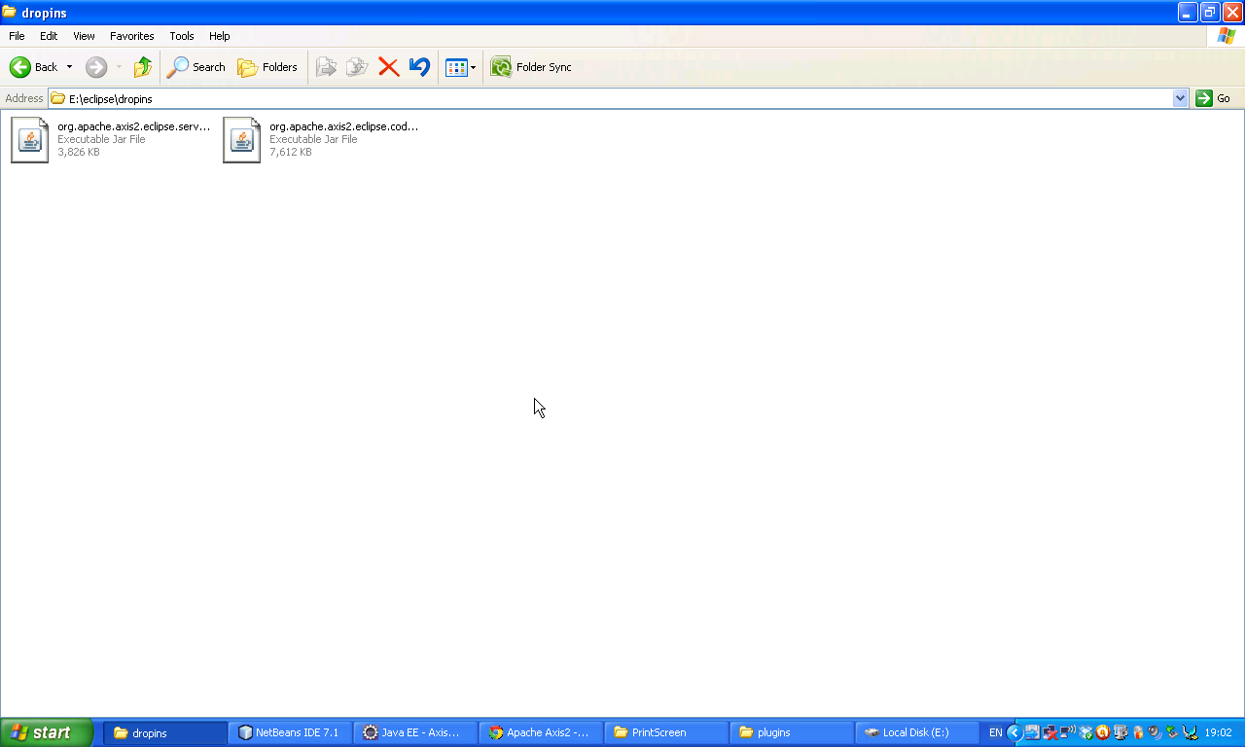

Now open Eclipse IDE. E:\eclipse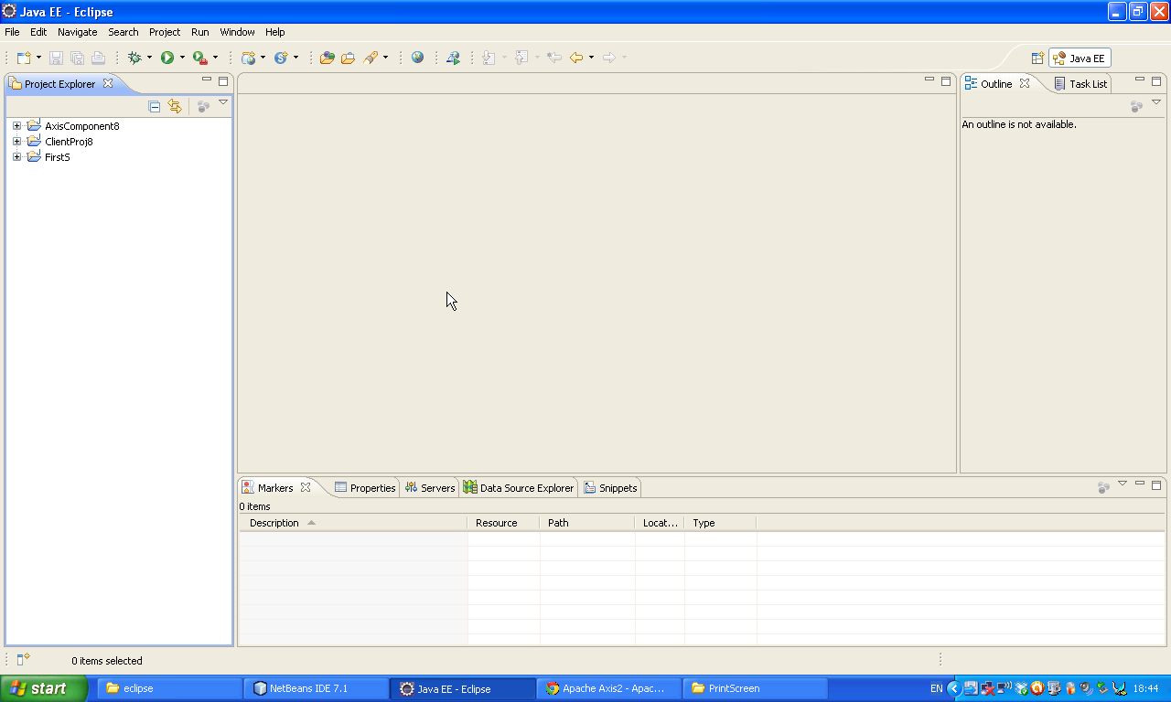Double click on it.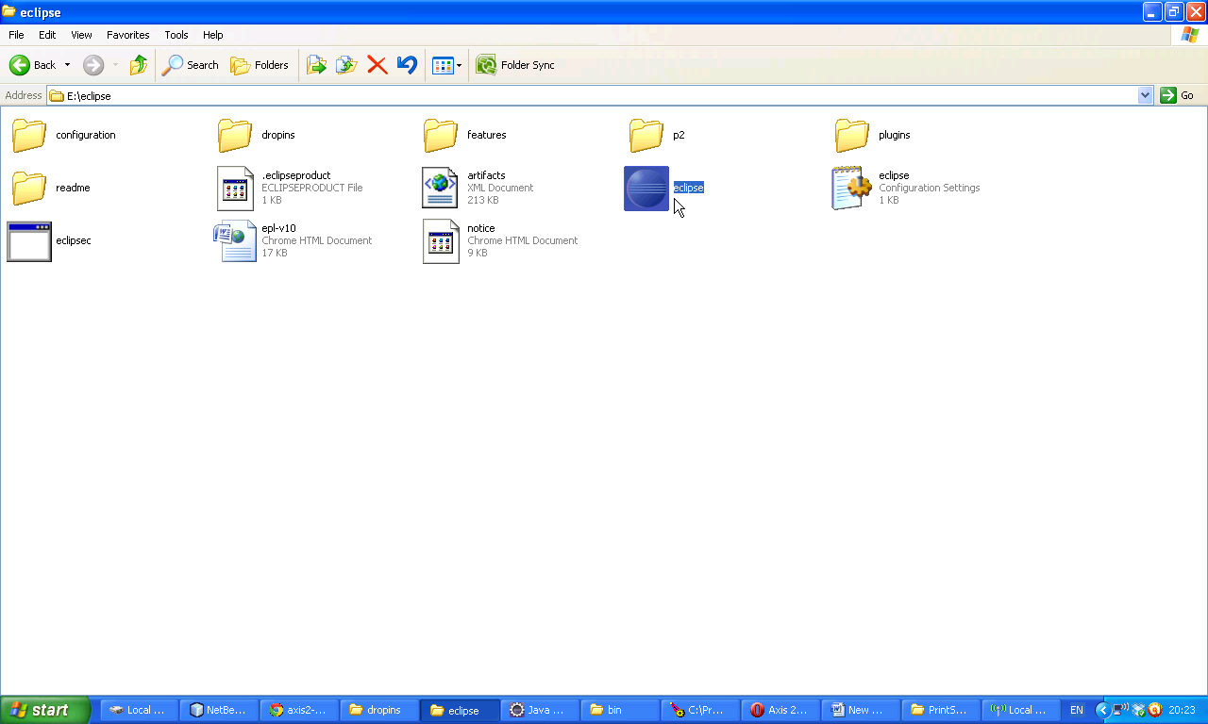

Now following window will open. Select New 🡪 Project

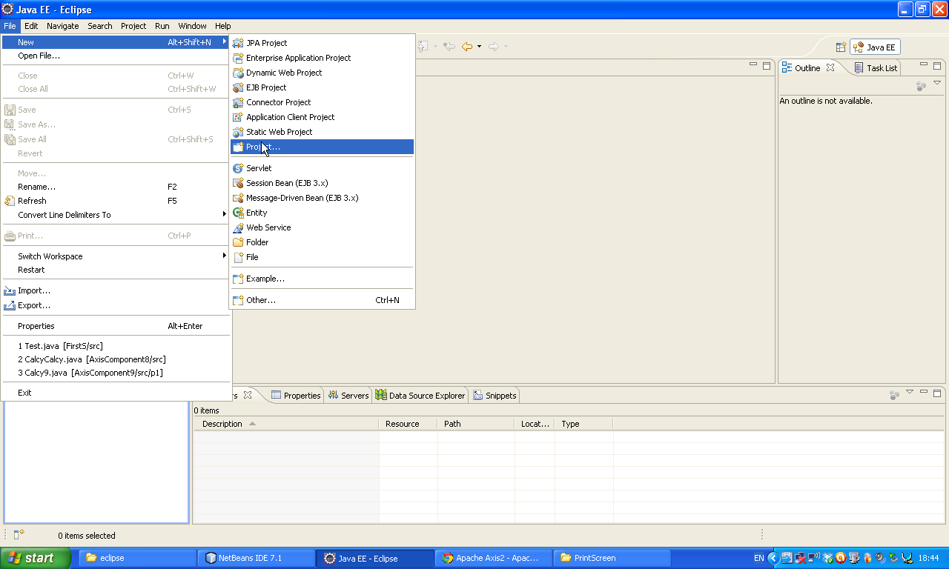Now select Java project and then double click on it.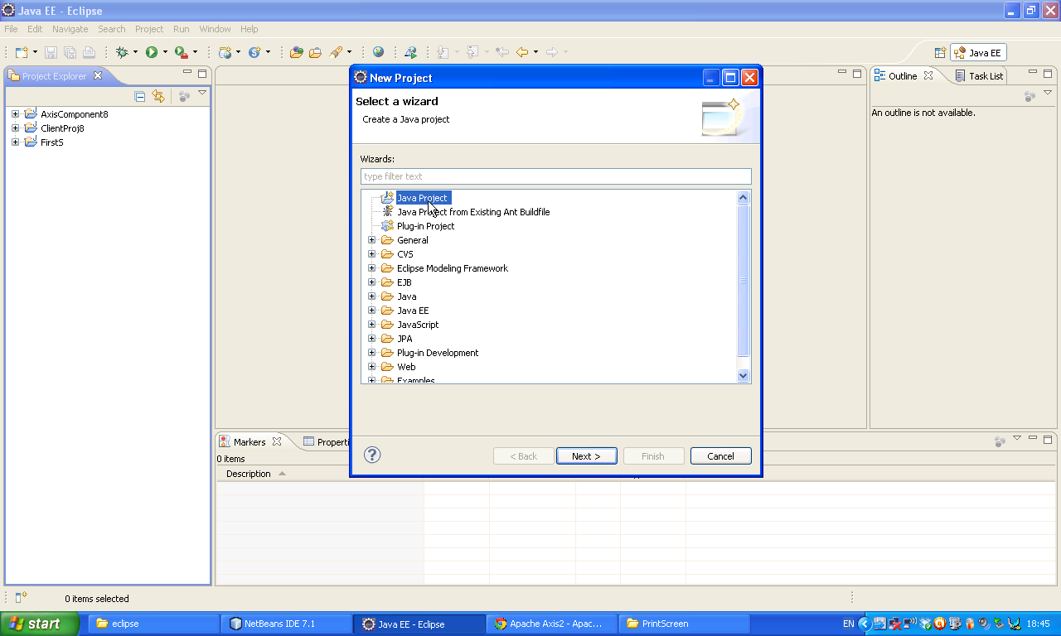

Now double click on the project and give a name. Here I gave AxisComponent2 🡪 Next

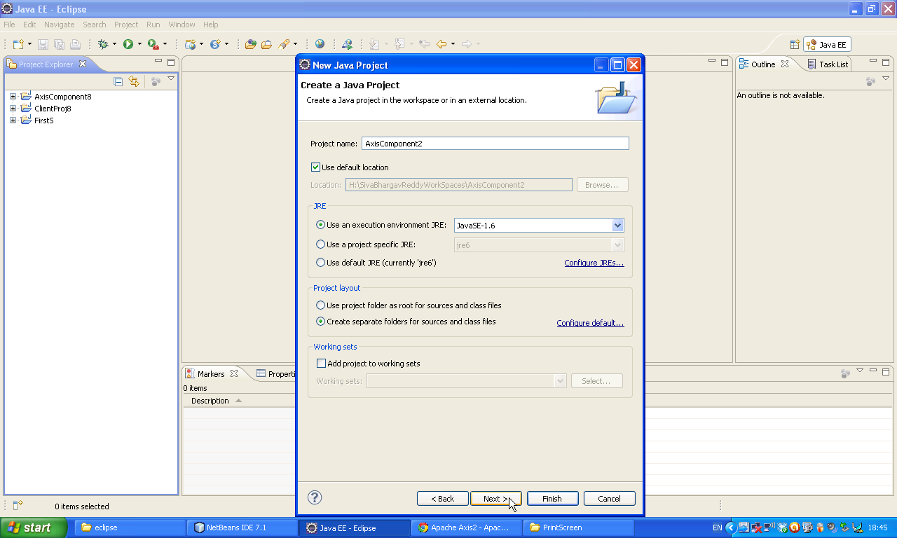Now click finish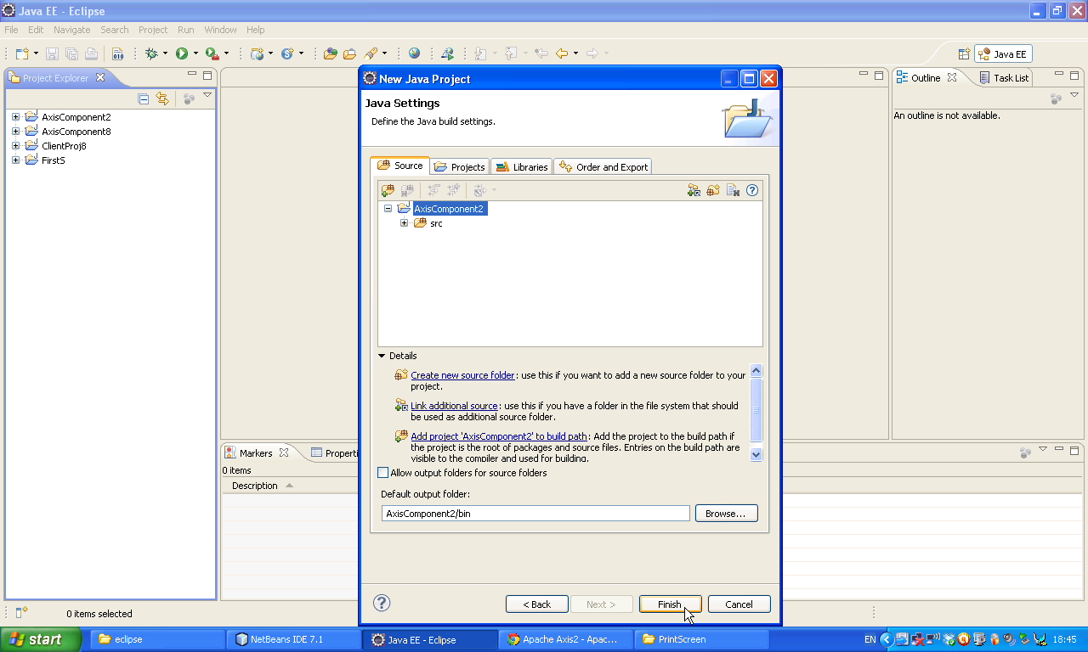

Now following window will appear. Rgiht click on the project

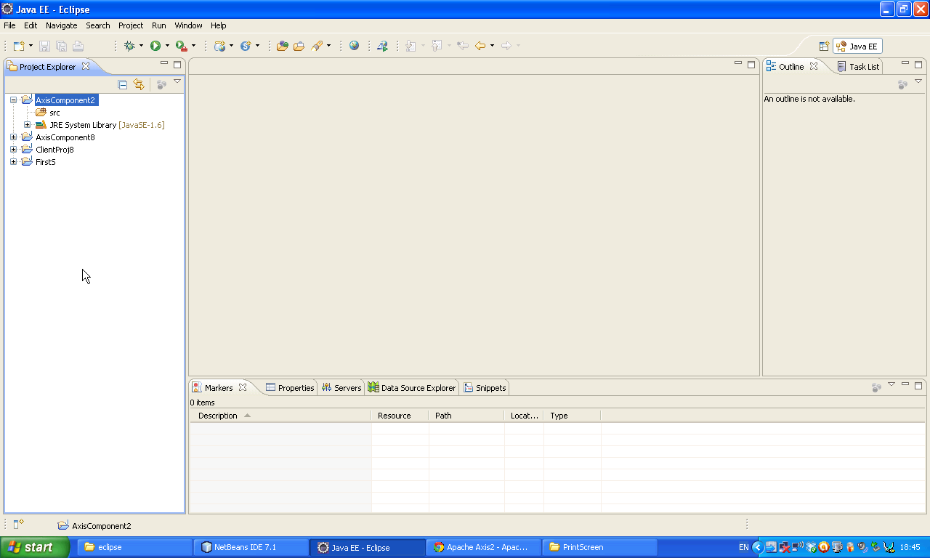Select New 🡪 Class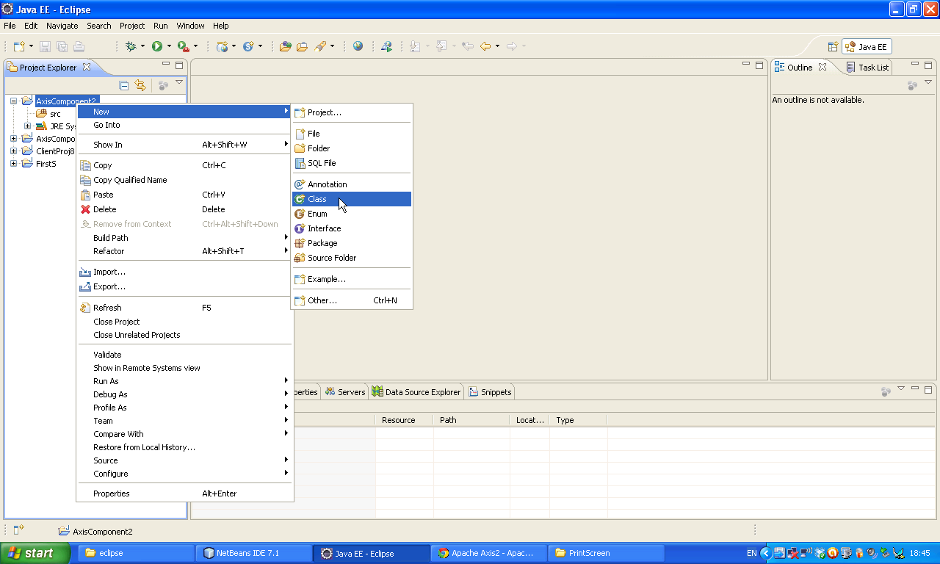

Give a name Sum or what ever you like.

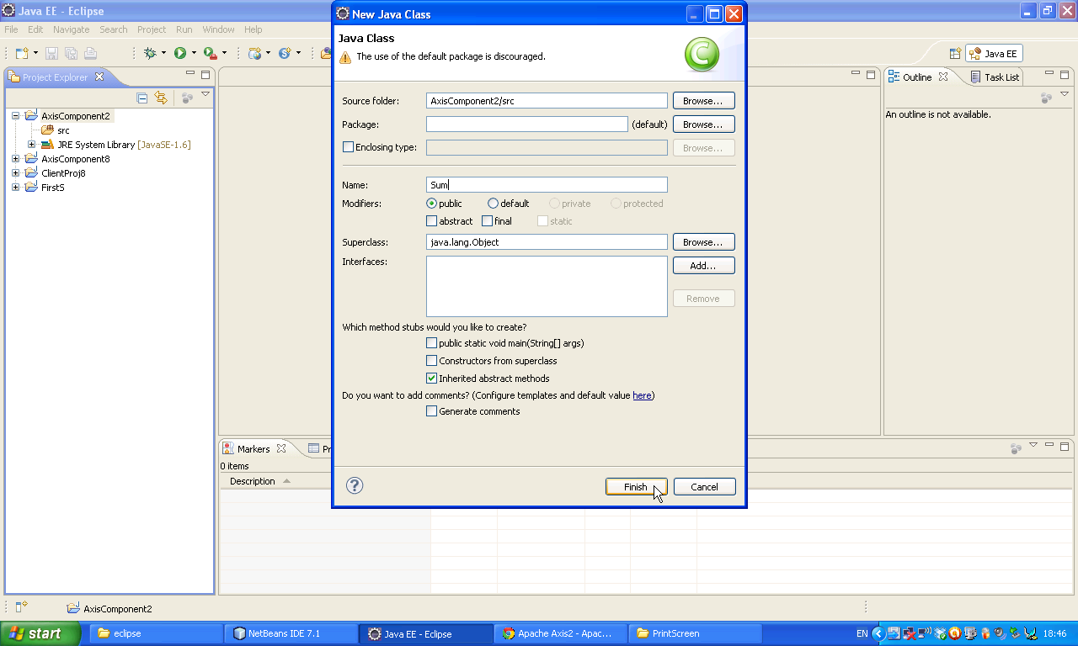Now following window will appear 🡪 Right click on the margin select Show Line numbers it will show line numbers.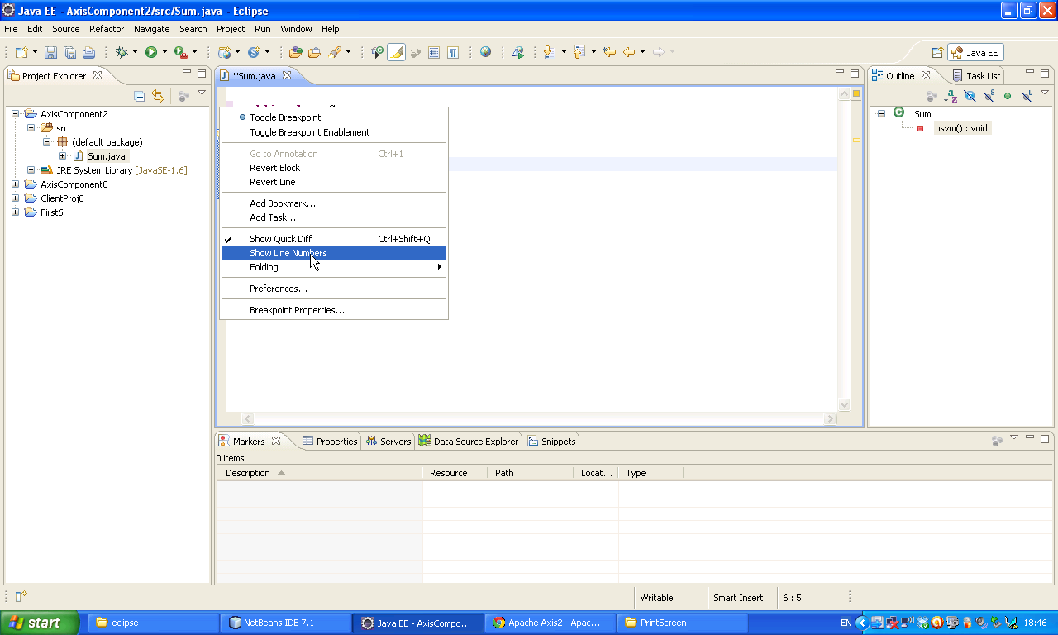

Now develop following code then we will get some compile time errors. Just click on red Beloon.

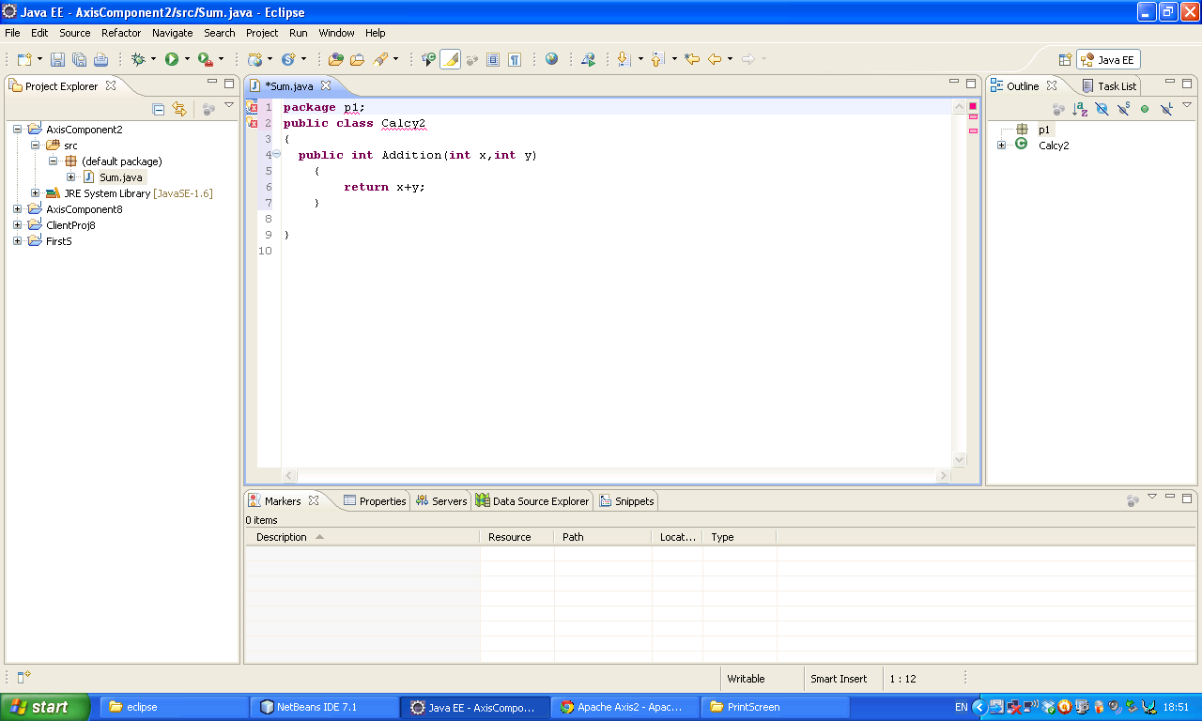It will show following message just select it.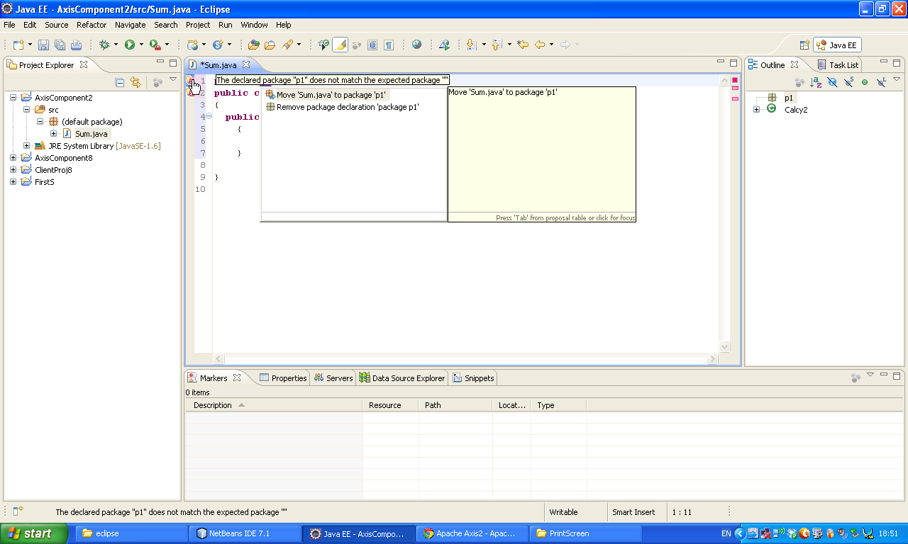

Do as above for second beloon also.

F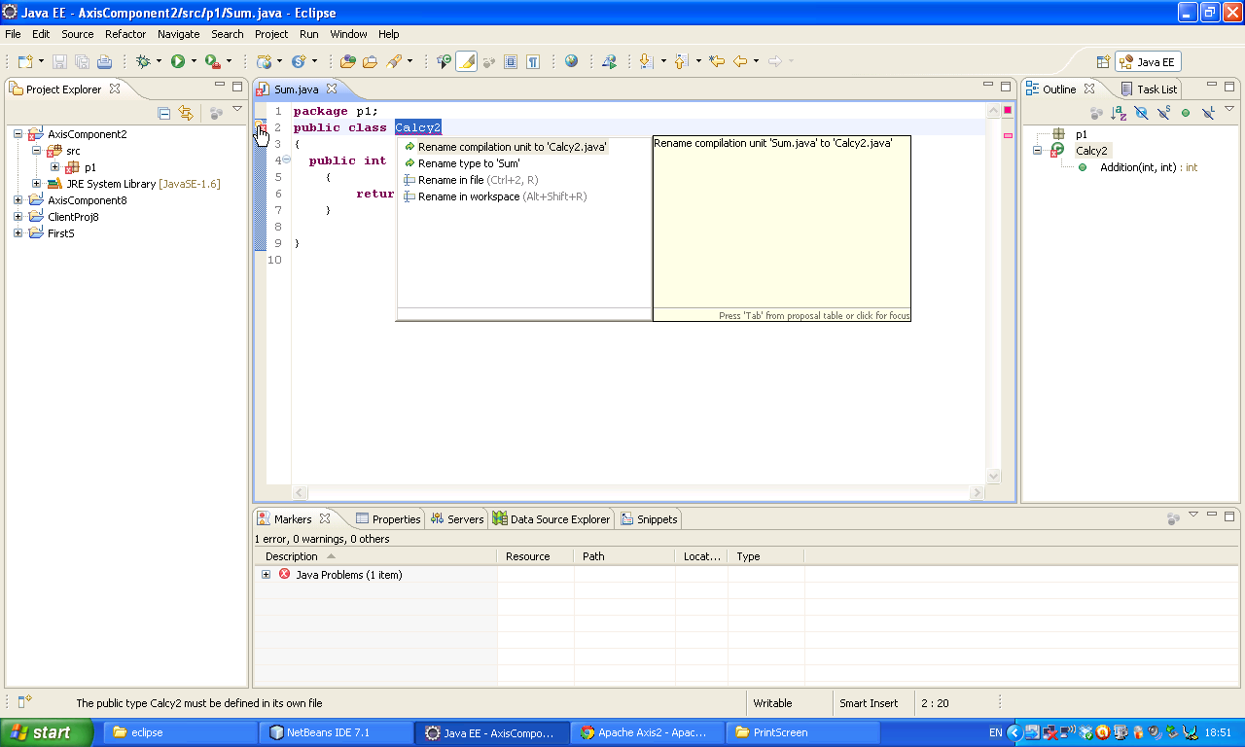Finally we will get particular code.

**package** p1;

**public** **class** Calcy2

{

**public** **int** Addition(**int** x,**int** y)

{

**return** x+y;

}

}

This is the window with paricular code

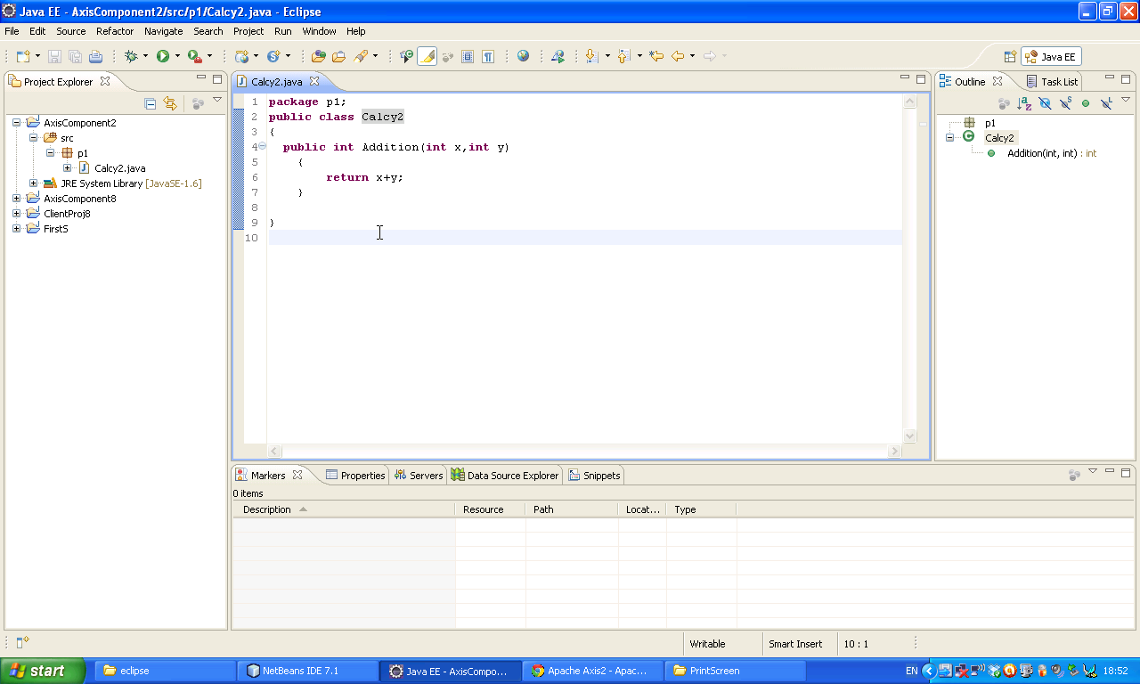

Now Right Click on the project 🡪 New 🡪 Other 🡪 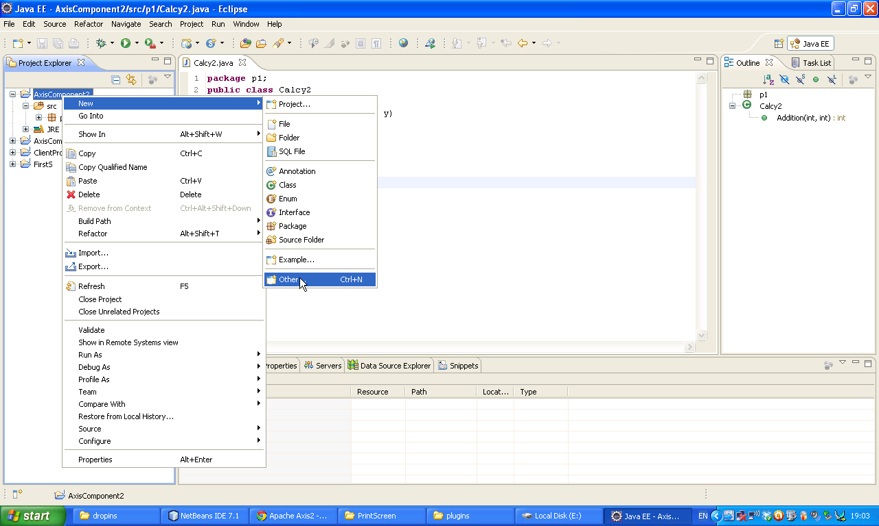Select Axis2 wizards 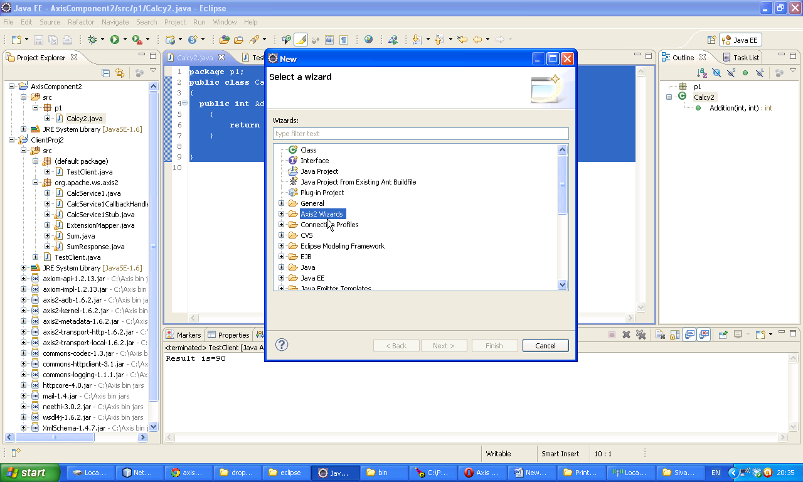

Drill down it and then select Axis2 Service Archiver.

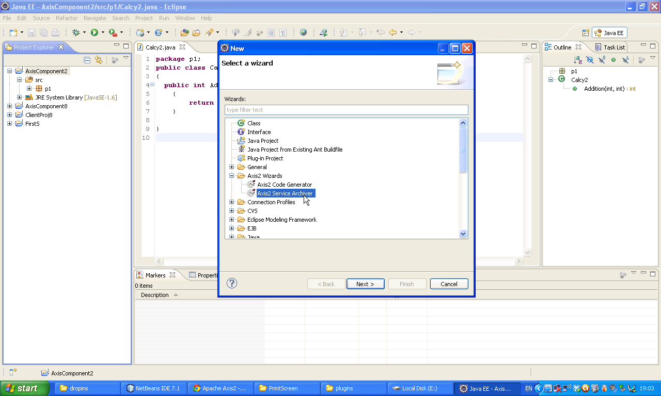It will ask Class File location. Now give your project folder bin directory location, afterwards Click Next

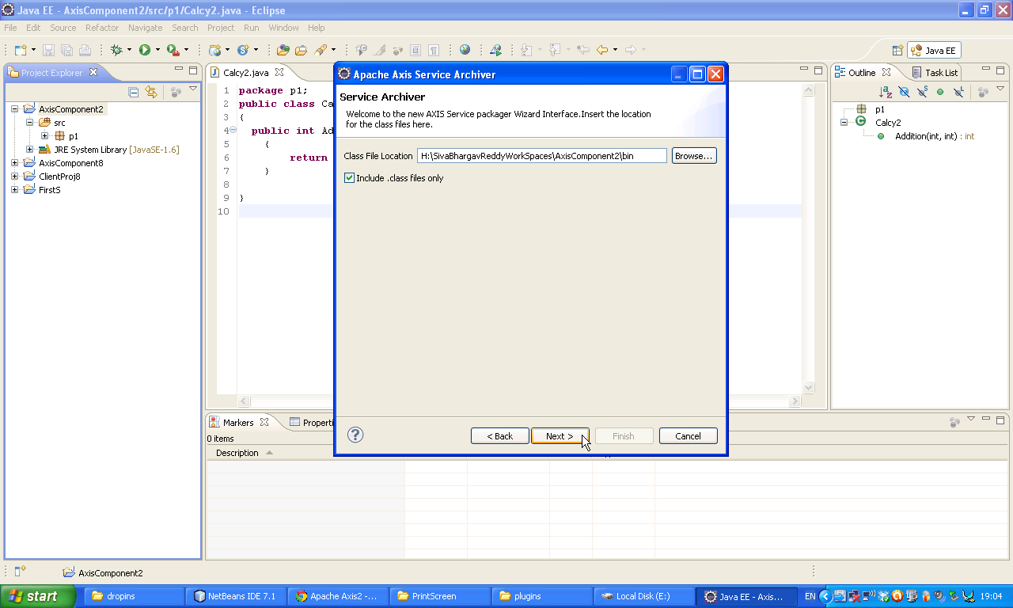

Now Click put ✓ for skip WSDL

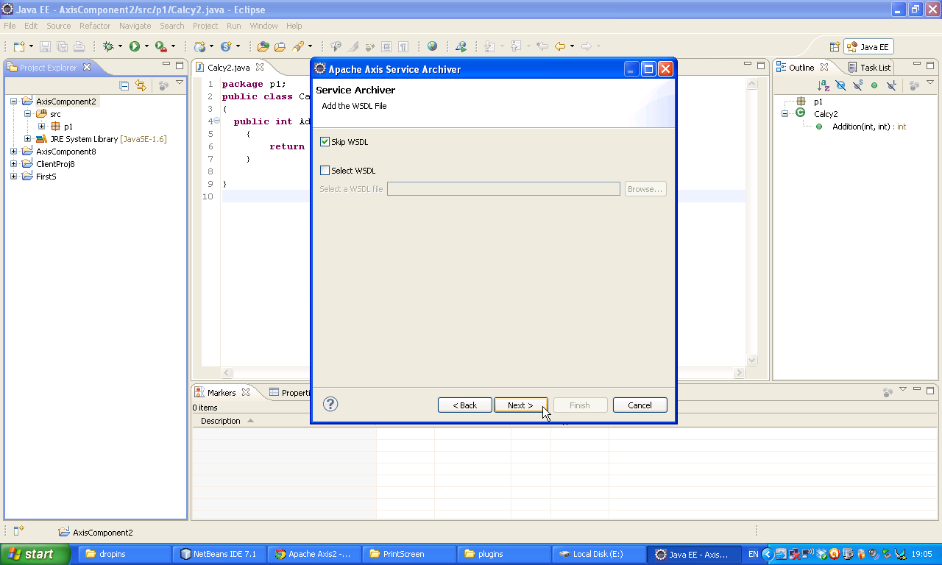Now Click next 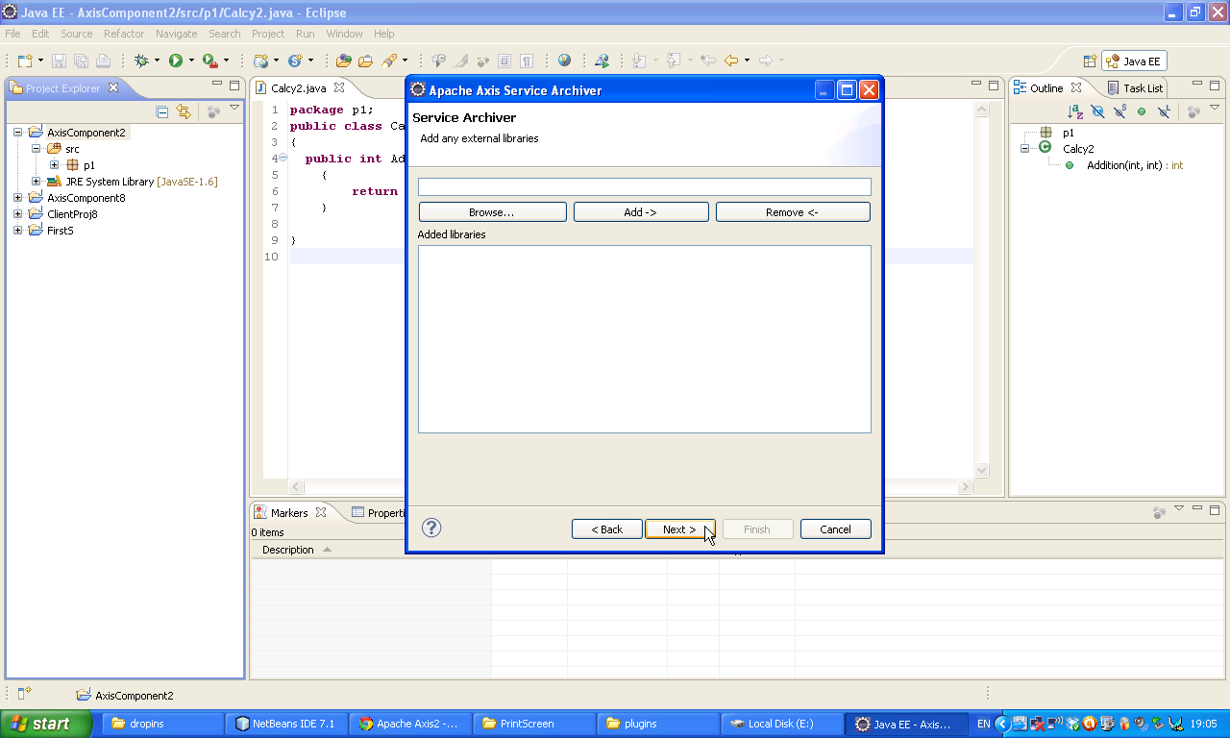

Click Next

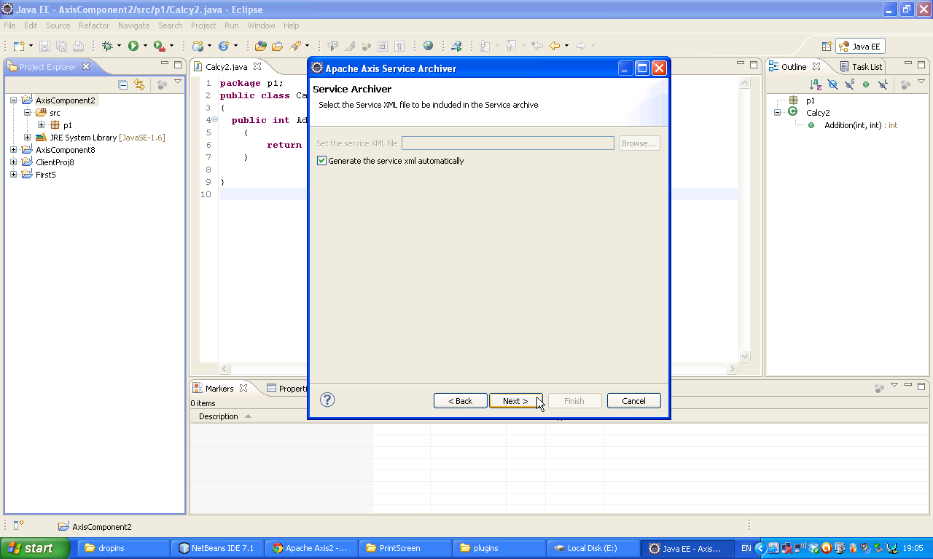Now give any name as Service Name and then select our class with package and then click load we will get our method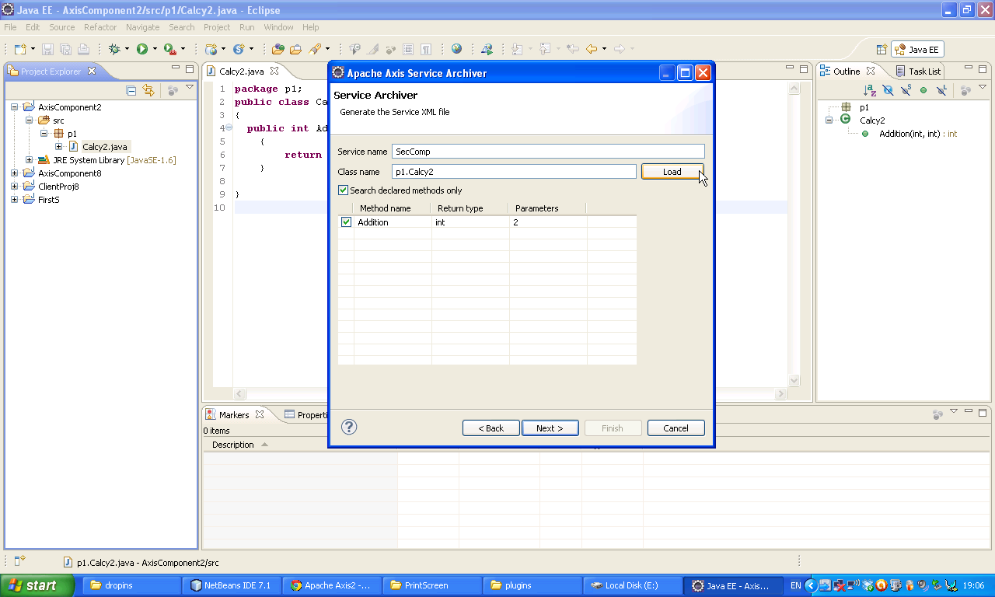

Now click on Next

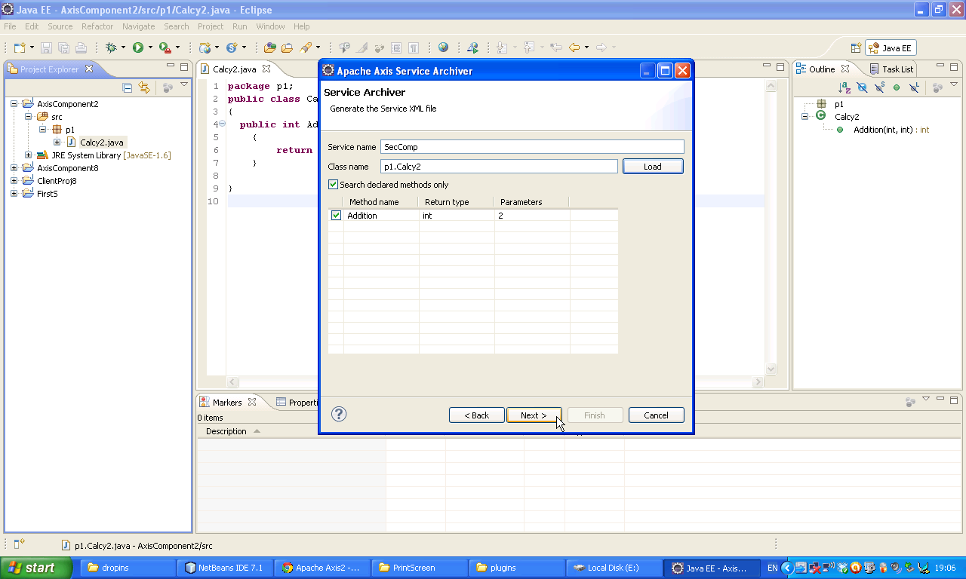Now select Output File location 🡪 Browse 🡪 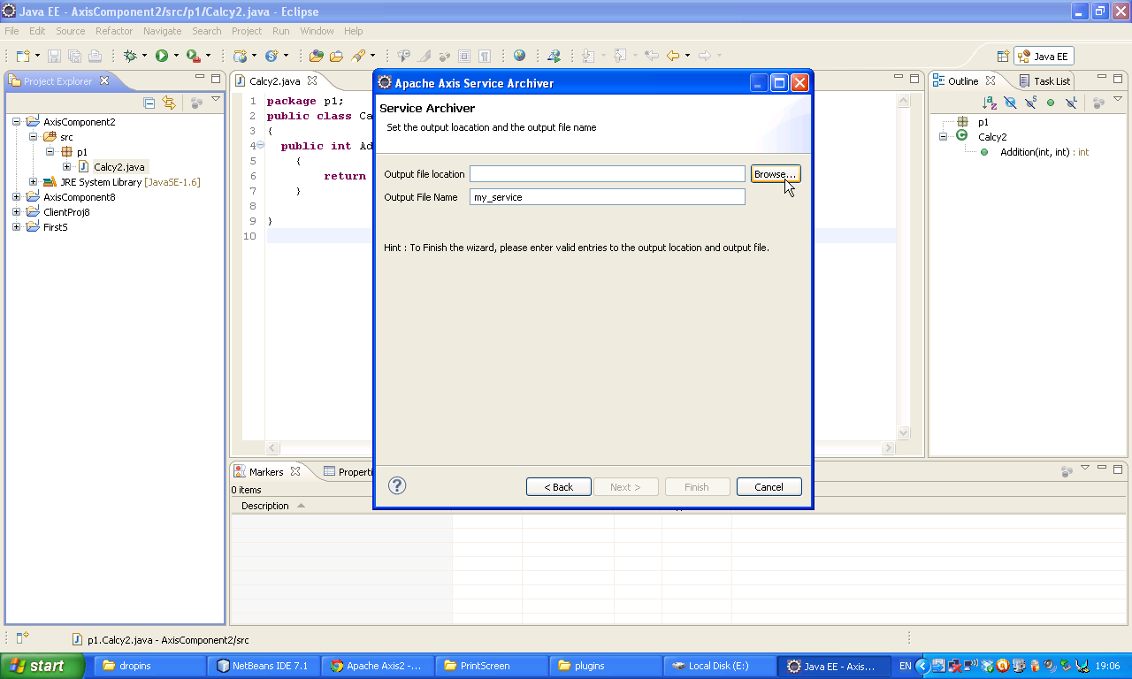

Give C:\Program Files\Apache Software Foundation\Tomcat 6.0\webapps\axis2\WEB-INF\services location

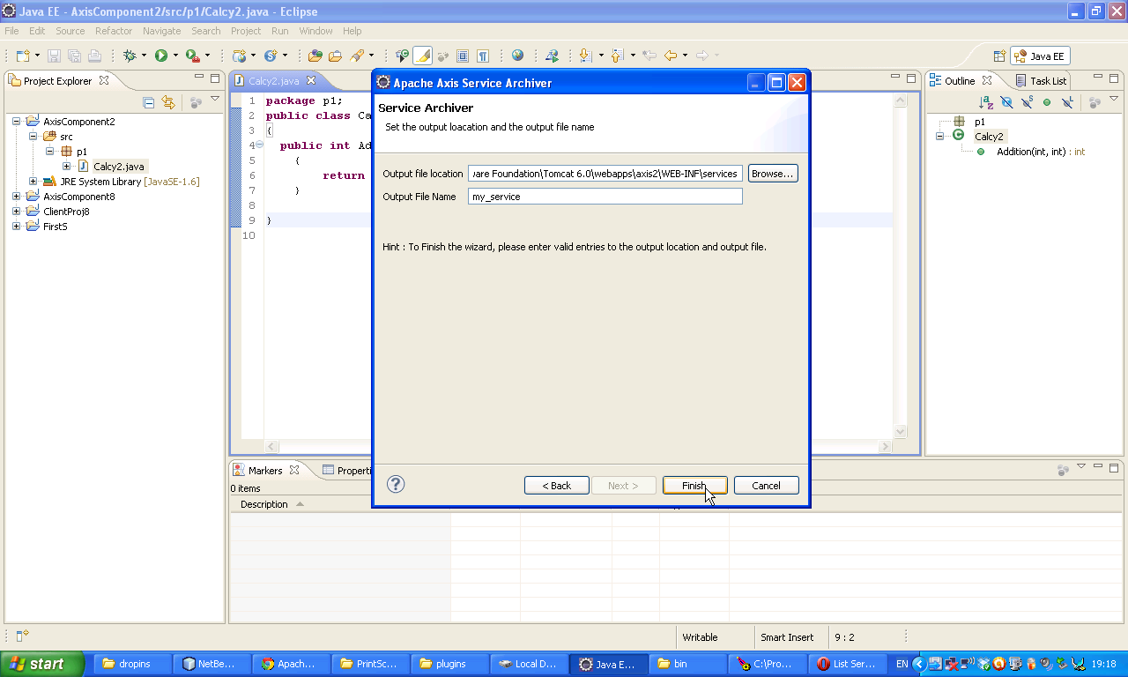Now Click on Finish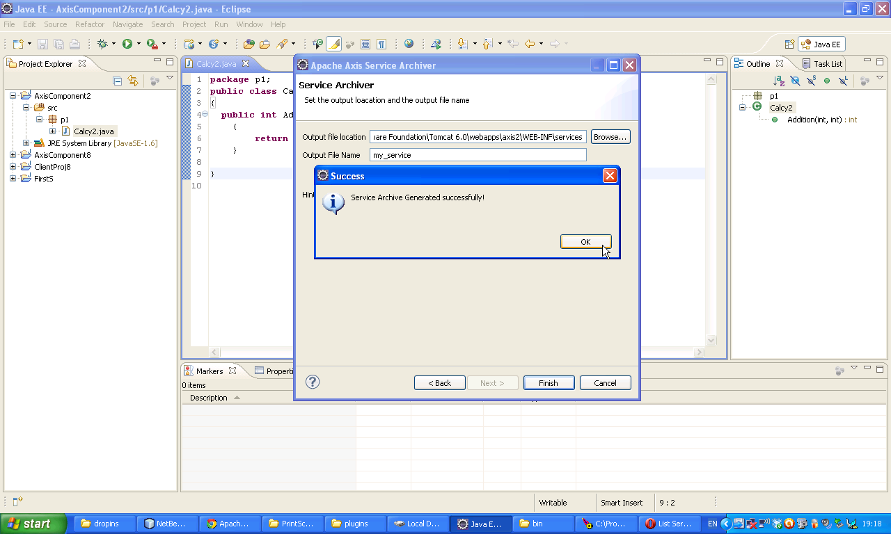

Open Tomcat browser with following url <http://localhost:5050/axis22> then following window will be appear

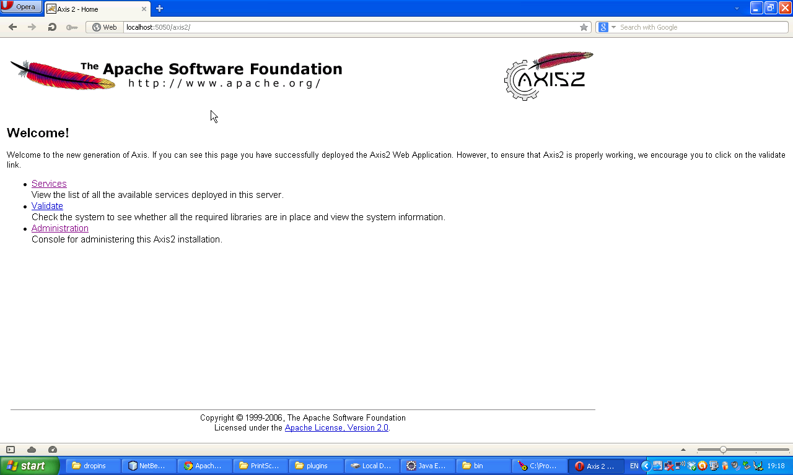Now select services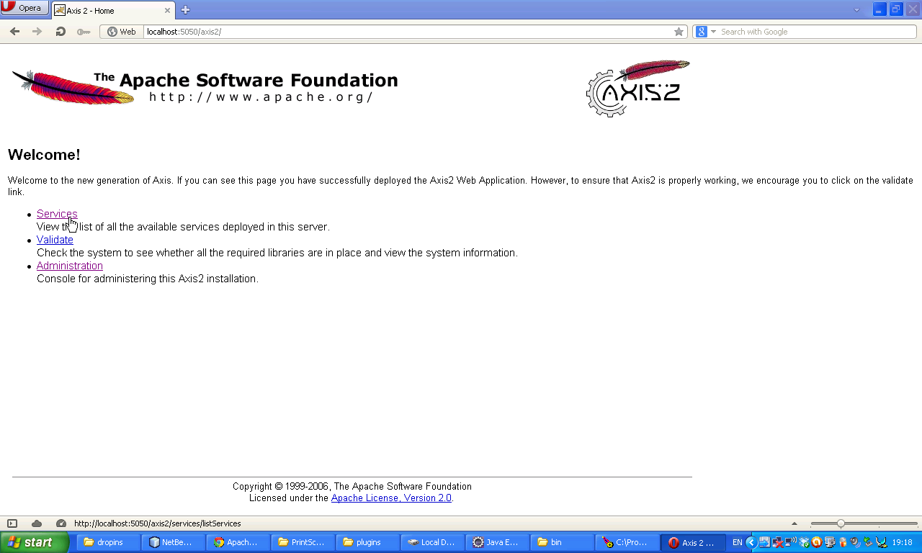

Now select CalcService1

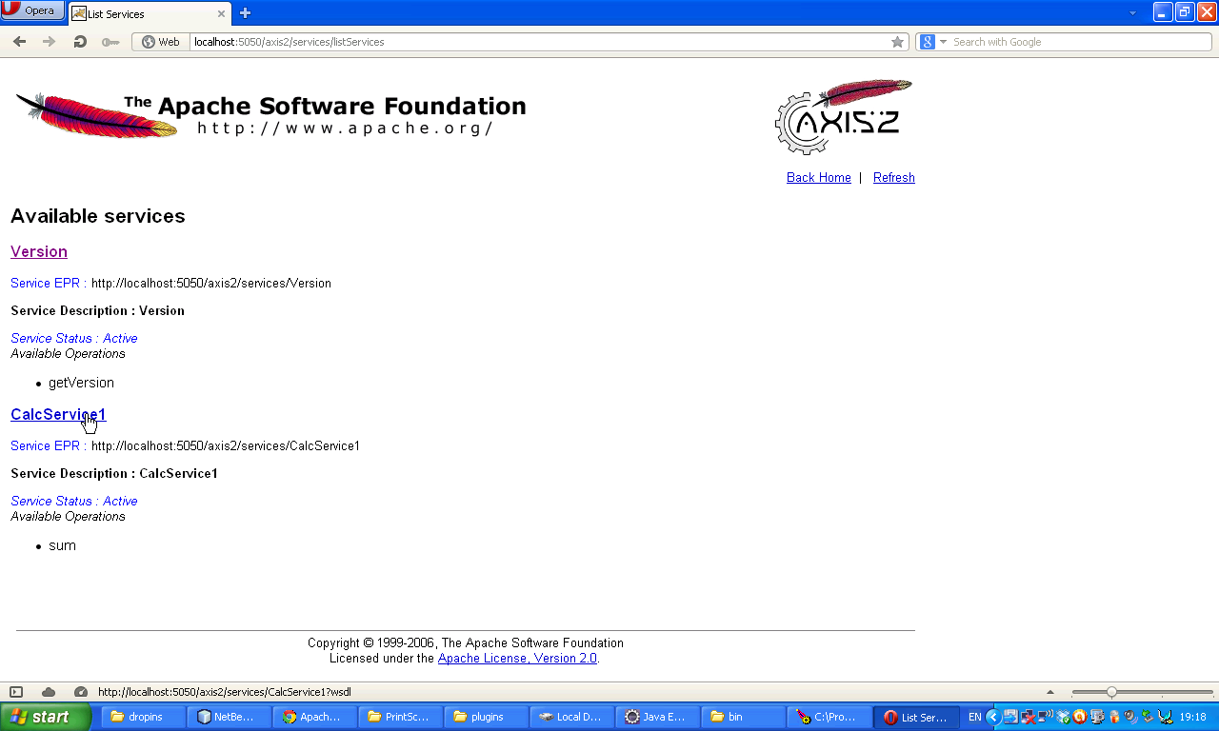Now following WSDL document will come. Copy the url of the that WSDL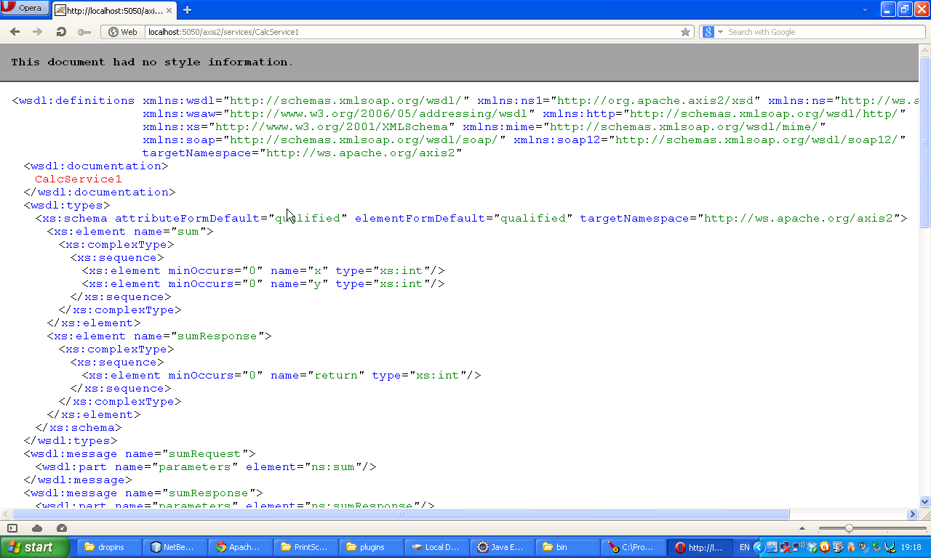

Now again come to the Eclipse IDE. Select New 🡪 Project

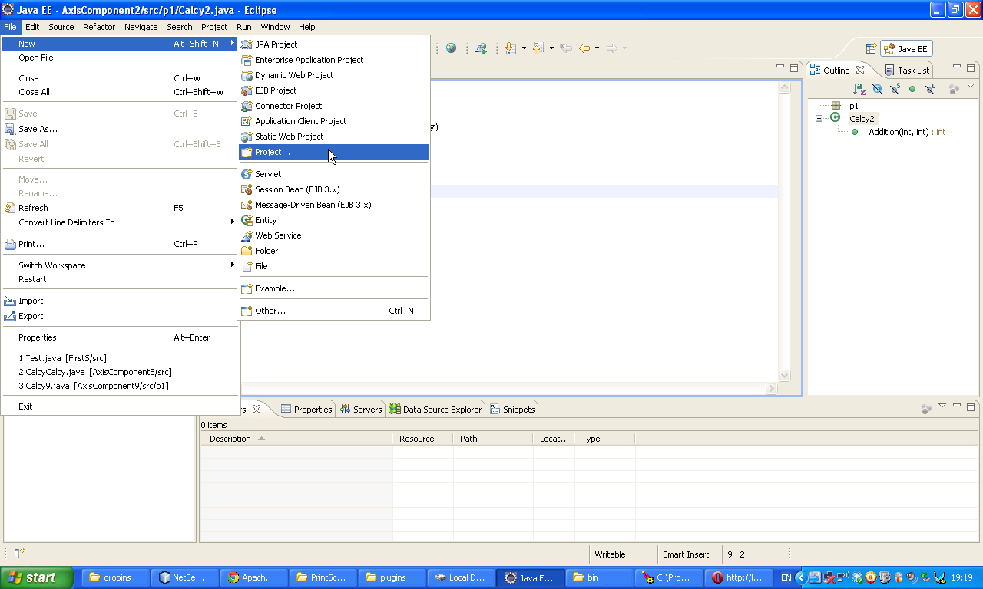Now select Java project double click on it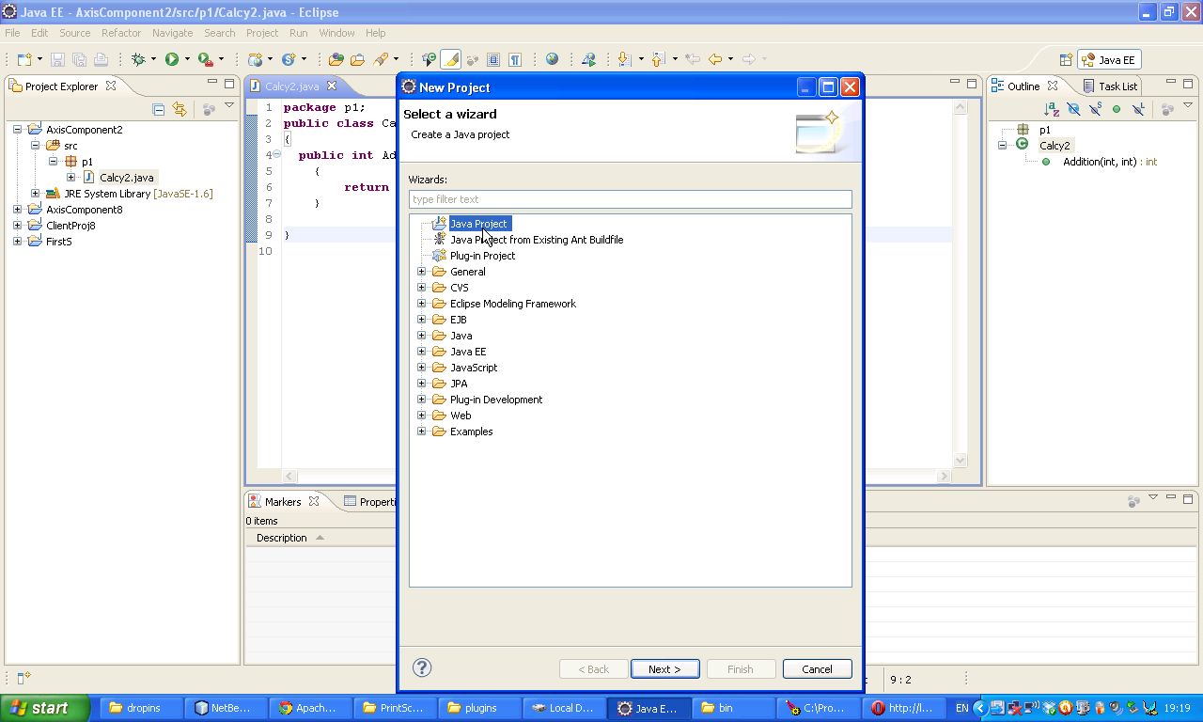

Give a Project name I gave ClientProject2 Click next.

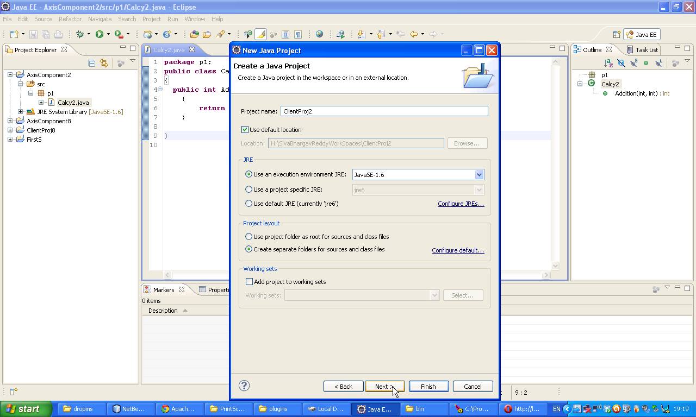N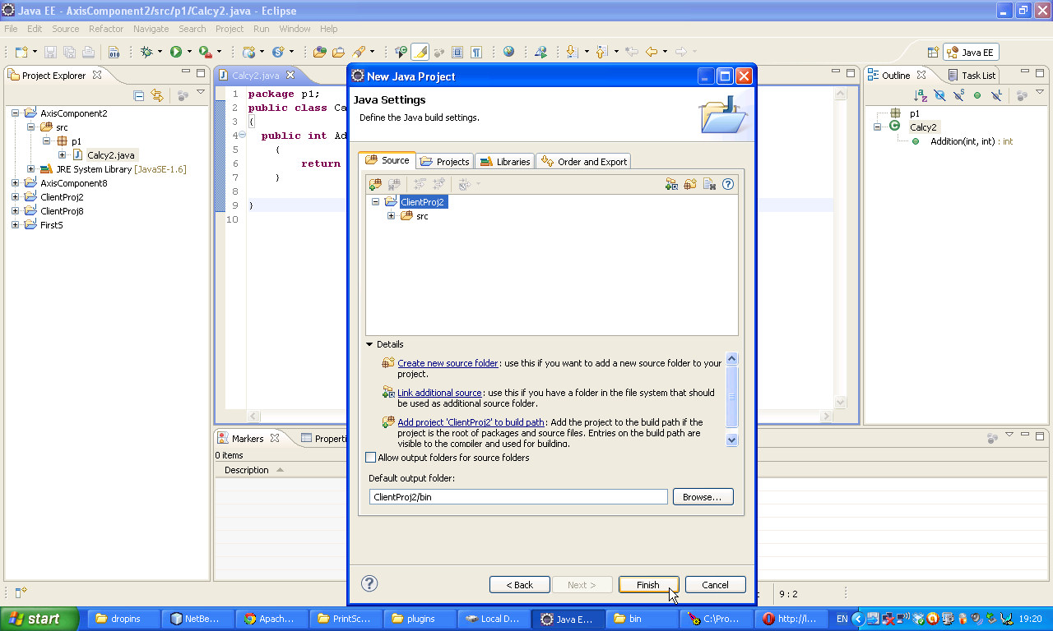

Now expand our project

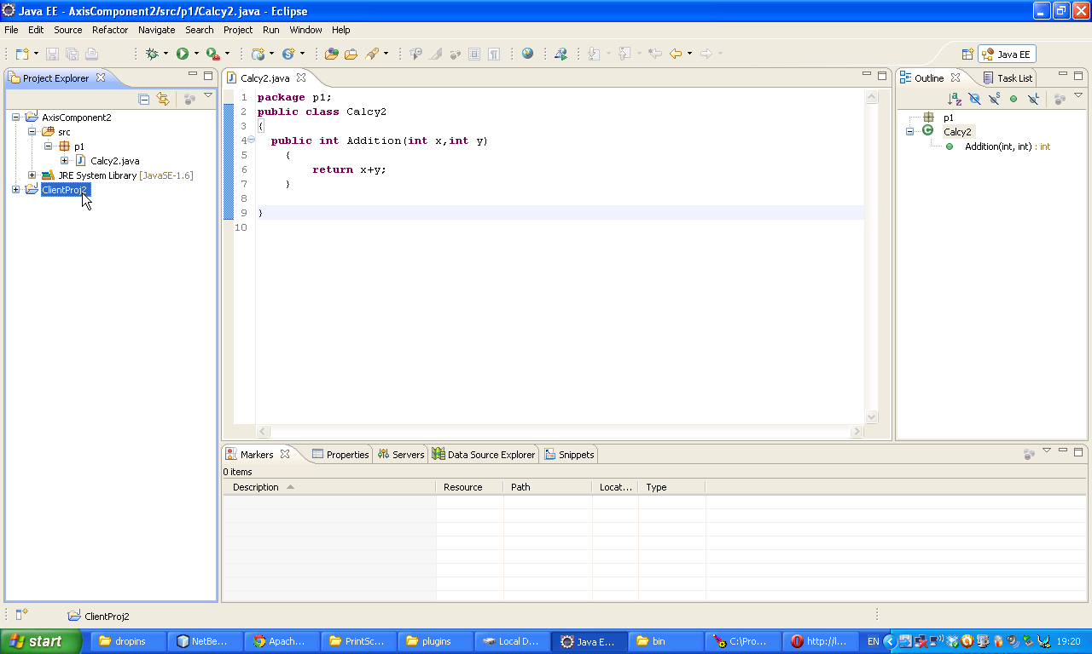Now select JRE System Library and then right click on it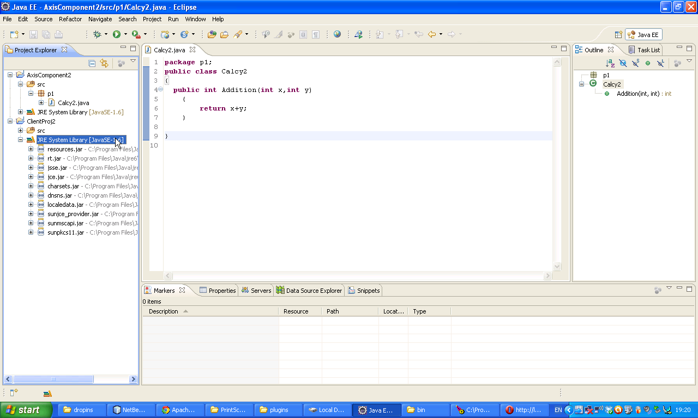

Now select configure build path

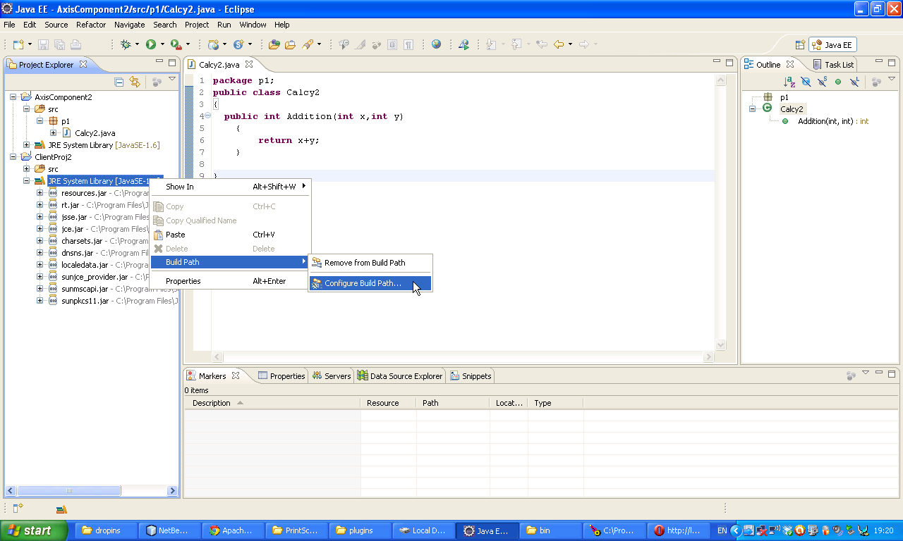Click on Add External Jars.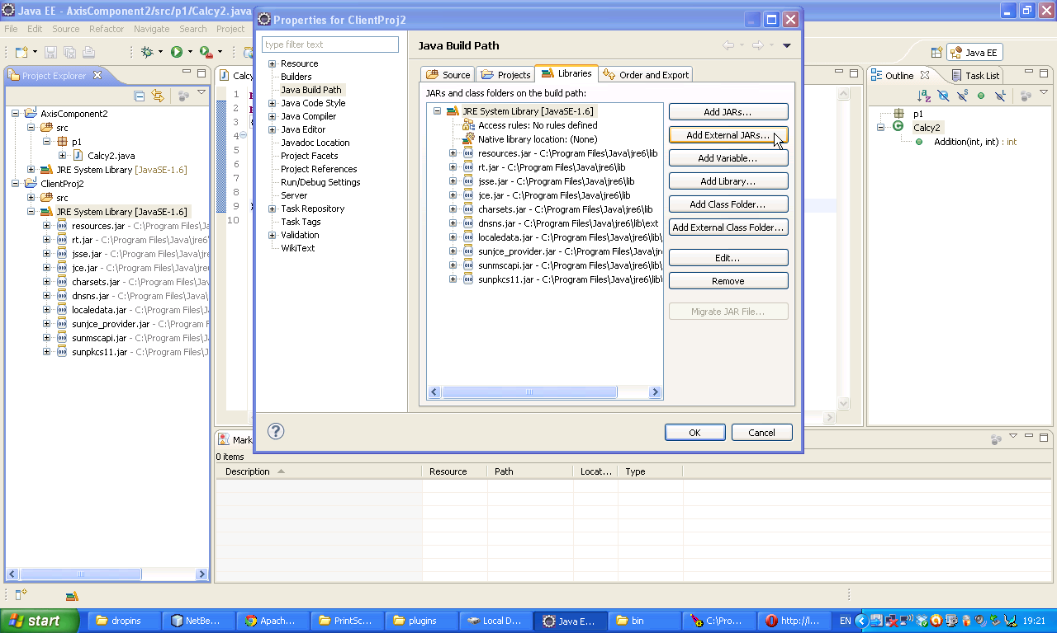

Now select following 15 jars which are available in E:\AXIS\axis2-1.6.2\lib. So I kept all required jars in a single folder. For jars please maximize window and observe them. Total 15 jars

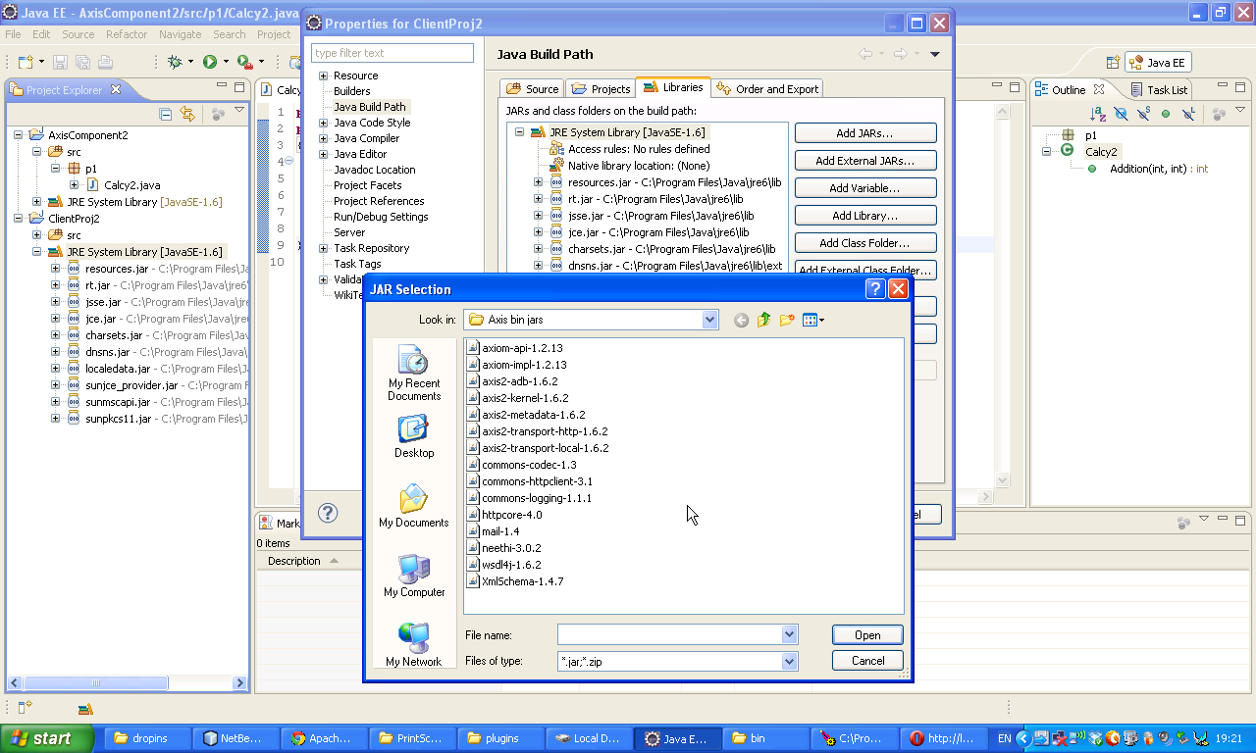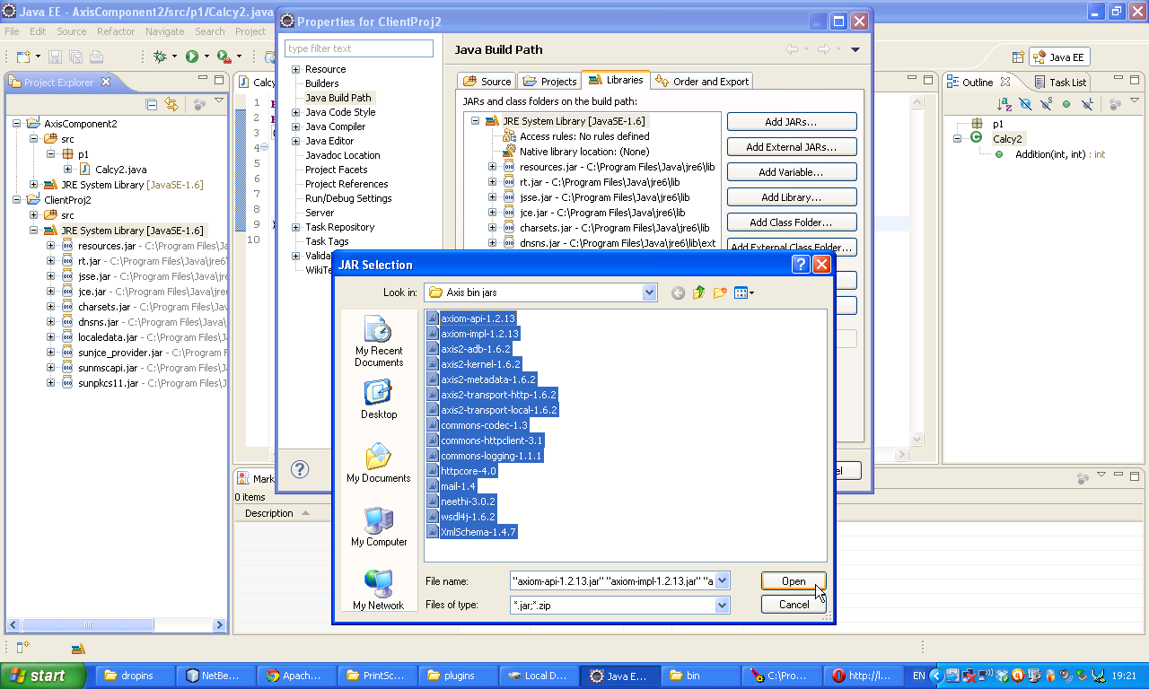

Click on OK

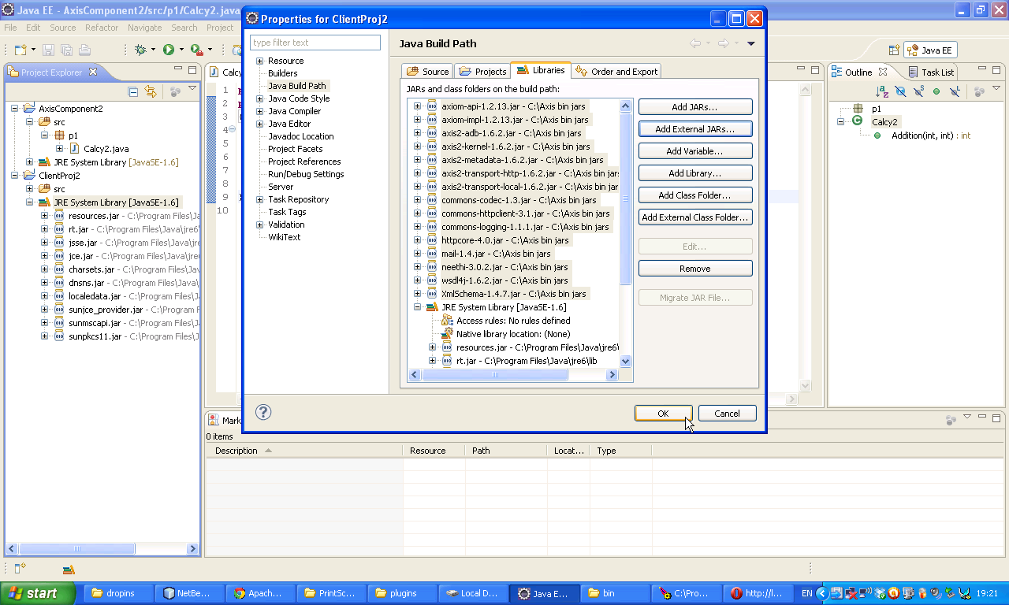Now Right Click on the project and then select others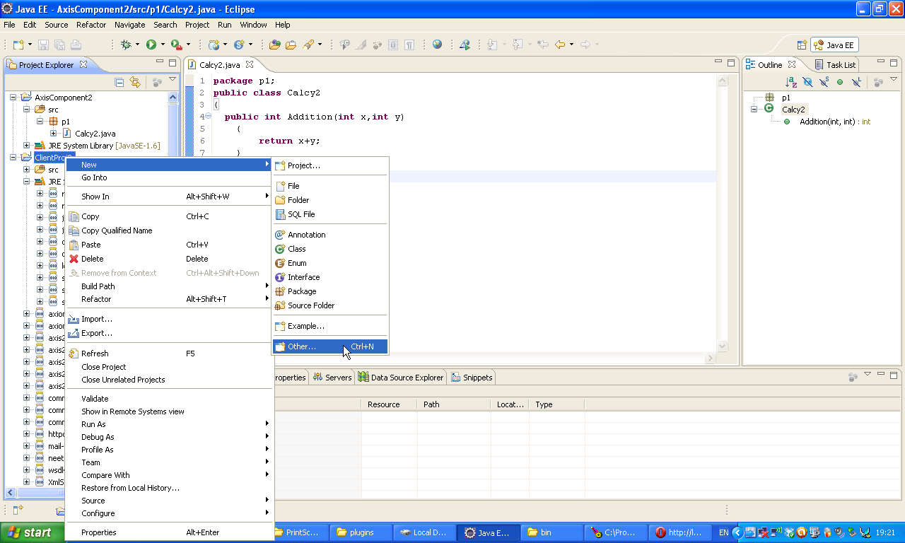

Select Axis2 Code Generator 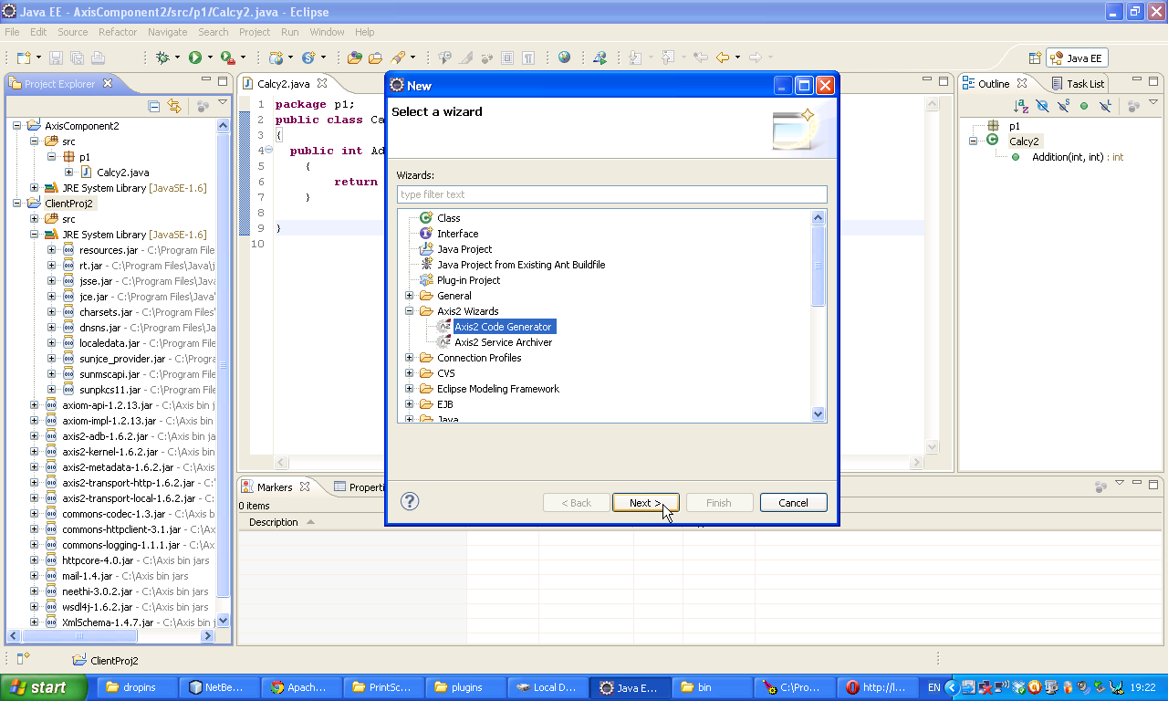Now select first radio buttom 🡪 Click Next

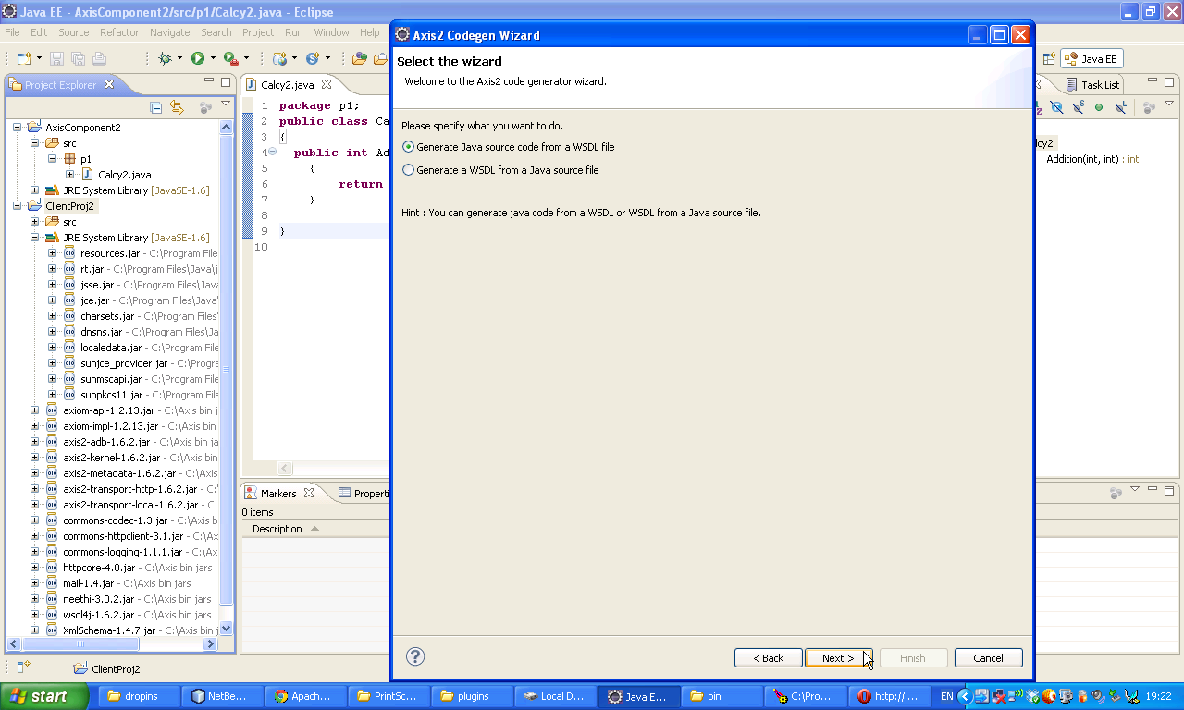

Now following window will appear 🡪 select our project where ever it has been located🡪 Finish Don’t select another location.

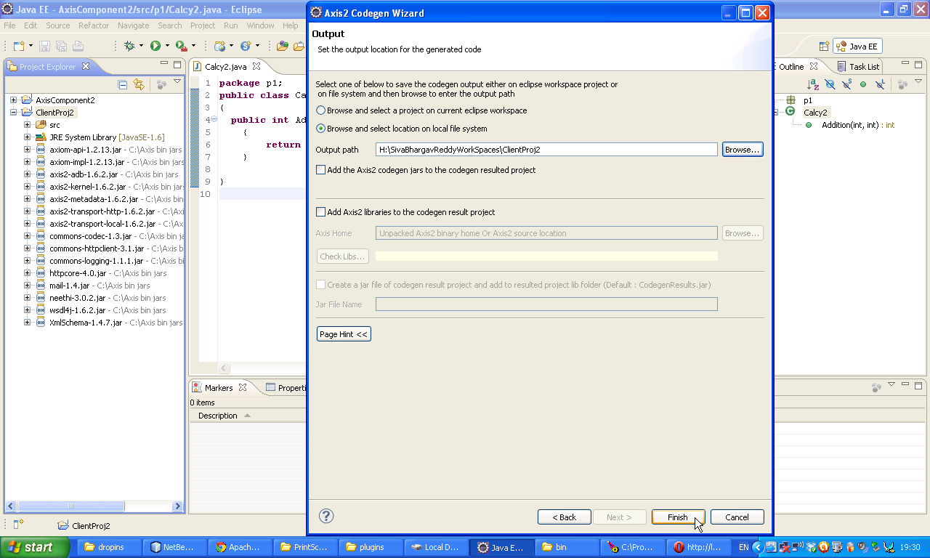Now following message will come 🡪 Ok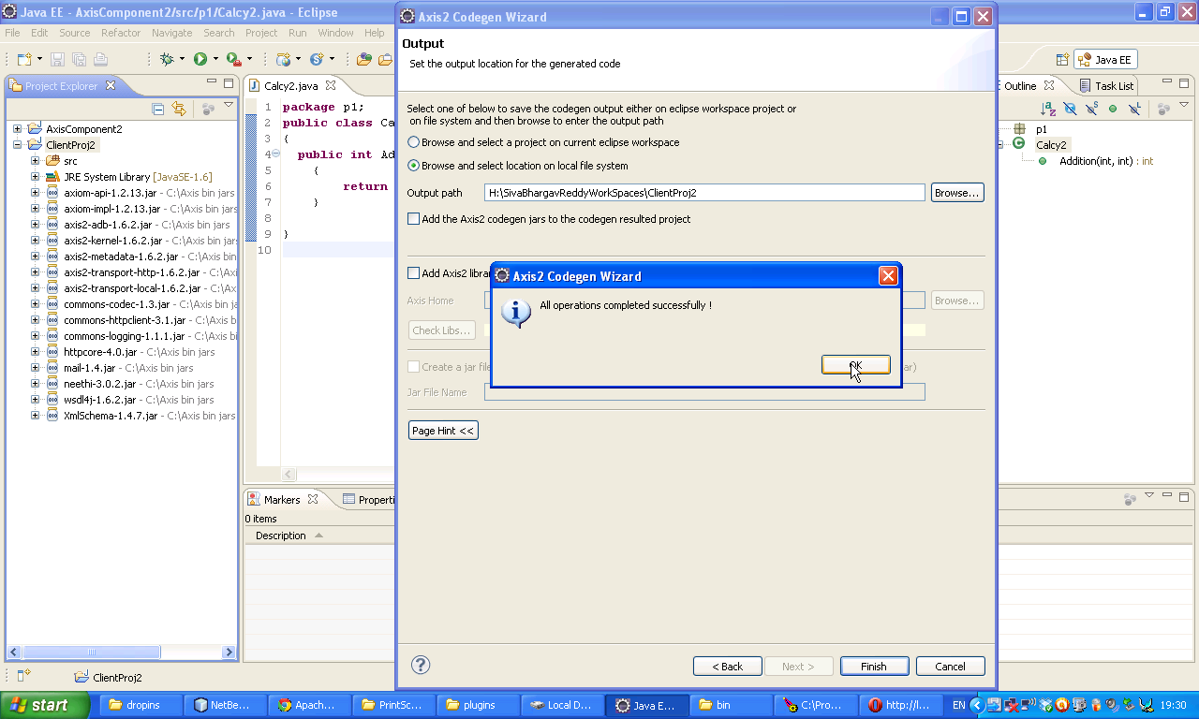

Now Right Click on our Client project select Refresh 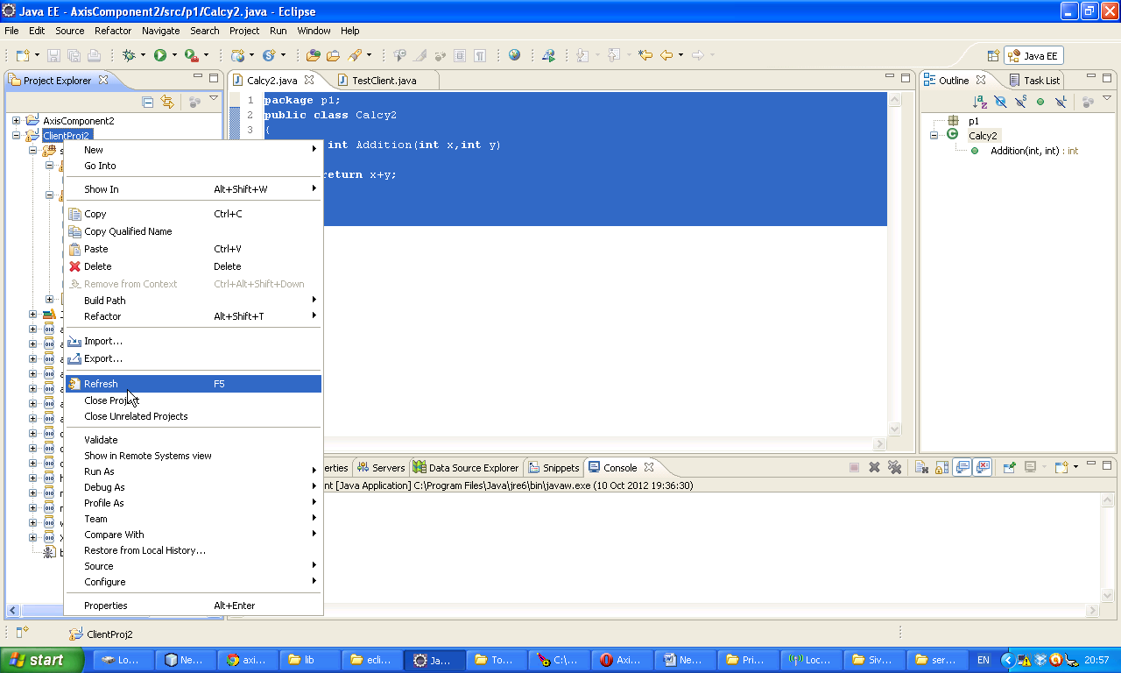

Now Ensure that org.apache.ws.axis2 package is availabe in your Client project or not. 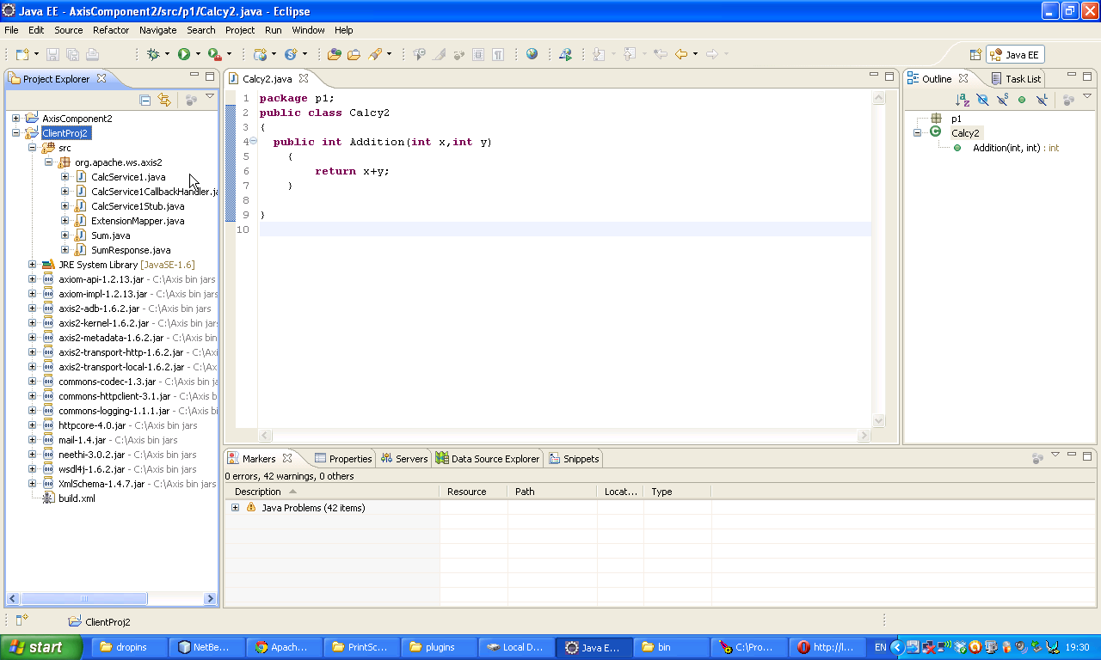

H

Now Right Click on our project and then select class.

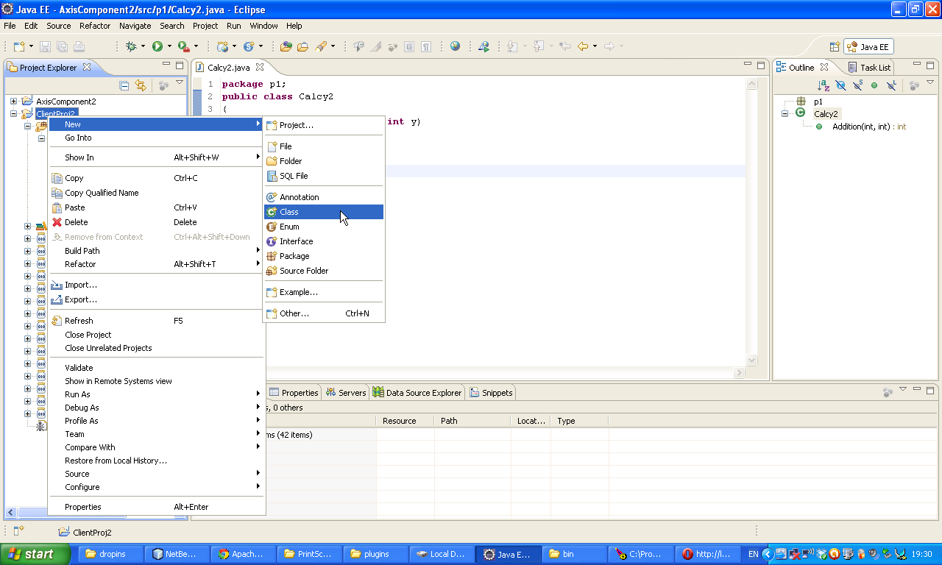Give a name Test Client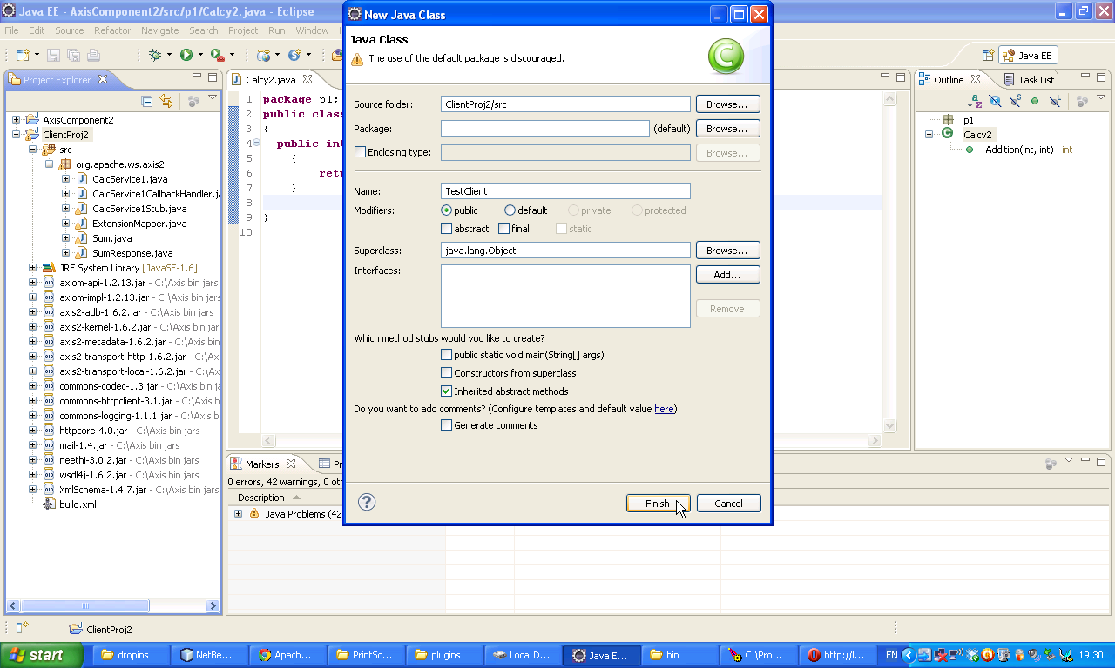

Now develop our source code here.

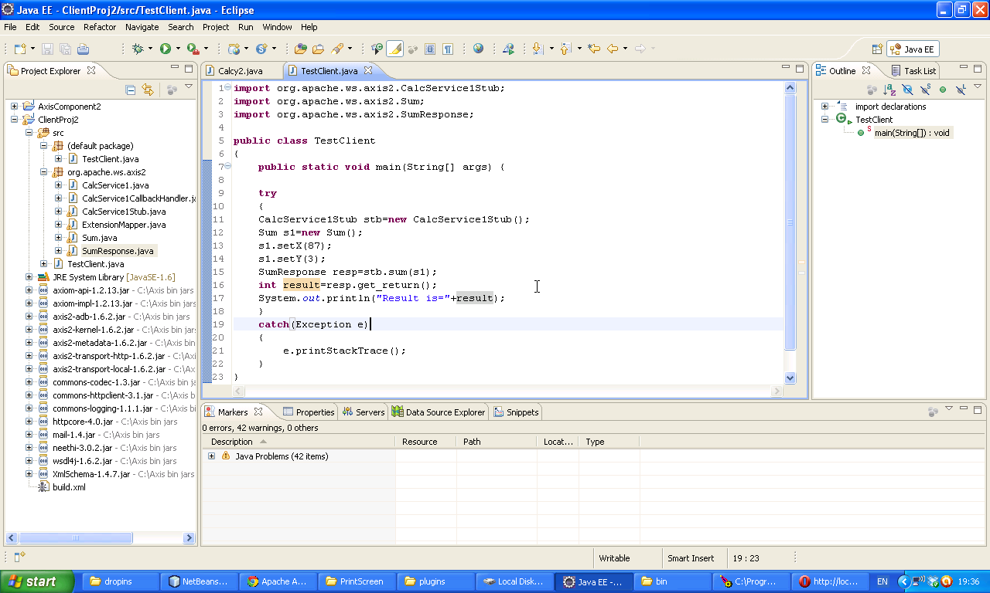

**import** org.apache.ws.axis2.CalcService1Stub;

**import** org.apache.ws.axis2.Sum;

**import** org.apache.ws.axis2.SumResponse;

**public** **class** TestClient

{

**public** **static** **void** main(String[] args) {

**try**

{

CalcService1Stub stb=**new** CalcService1Stub();

Sum s1=**new** Sum();

s1.setX(87);

s1.setY(3);

SumResponse resp=stb.sum(s1);

**int** result=resp.get_return();

System.*out*.println("Result is="+result);

}

**catch**(Exception e)

{

e.printStackTrace();

}

}

}

Right Click on the project 🡪 Run As 🡪 Java Application

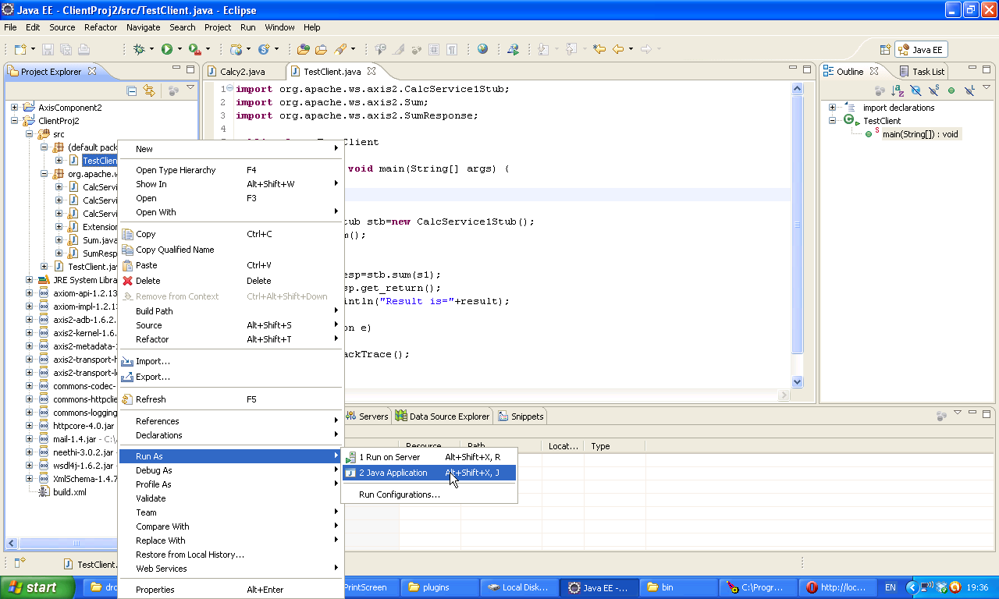We will get the following output.

